Friendship Table Tennis Trip

To China 10-22 April 2002
By Alex Sumeri

Yong Fan’s trip was a wonderful introduction to China for most of the nine of us who had never visited China or Asia. We were able to play table tennis matches with a wide range of players (adult amateurs, young 14-16-year-old professionals, middle school and elementary school students). We were also able to see and do things that ordinary tourists just are not exposed to. We were able to interact with Chinese sports ministers (provincial and city), school officials, elected officials (city mayor), businessmen, teachers and of course the table tennis players and often some of their family members. We were able to visit facilities with table tennis programs from kindergarten age to elementary and middle school age, young professional table tennis school age and adult amateur club players and play friendship matches with many of them. We were treated like family members and honored guests at each of the facilities we visited and treated to a wide variety of Chinese dishes at restaurant luncheon and dinner banquets. These generally included up to 40 different dishes and constantly replenished tea, juice, wine or beer for continuous individual and group toasts. In addition, we were able to visit table tennis and sports shops, department stores, see agricultural and city life, and usual tourist attractions such as museums, tourist shops, tea tasting rooms, sauna and massage parlors and visit the tourist city of Qingdao on the East China Sea, Tiananmen Square, the Forbidden City and the Summer Palace in Beijing and the Great Wall.

We arrived in Beijing about 9:30 P.M. on 11 April after a 10.5-hour flight from Seattle, a 3-hour layover at Tokyo’s Narita Airport (looked at electronics gadgets and other tourist shops) and about a 3-hour flight to Beijing. Yong Fan’s ex-coach, a retired Sports Minister for the City of Zibo, met us at the airport with flowers for his protégé and a bus for our bags and us-a tight fit. We spent the night at an airport hotel in Beijing. The morning of 12 April began with a Chinese buffet at the hotel, which included a variety of vegetable dishes, dumplings, hot soup, breads and an egg station. We taught the egg cook how to make scrambled eggs. Then we re-loaded our bags, banner and ourselves into our mini-bus for the
seven-hour trip to the City of Zibo in Shandong Province to the southeast of Beijing. Yong’s coach accompanied us. Our drive through Beijing was over broad streets with four to six lanes. The two outside lanes generally were for bicycles, motorcycles, smaller or slower vehicles and were also used by farm vehicles. Horns are apparently indispensable to Chinese drivers as our driver often used it. Pedestrians have no right-of-way, even in marked crosswalks. A pedestrian crossing streets in heavy traffic, was often caught between vehicles going in opposite directions. There were huge apartment house complexes interspersed with factories and office buildings in and on the outskirts of Beijing and the other cities we drove through. The trip to Zibo was over modern four and six lane highways (toll roads). Highway travel provided an insight into the vast cultivated rural lands of China. The land we traversed was relatively flat and almost entirely cultivated and irrigated. One could see occasional factories or utility complexes in the distance. We saw occasional cooling towers; however I was informed that China does not rely on nuclear power plants. Power lines and their towers crisscrossed the farmlands along the way. We crossed rivers and apparent flood plains and saw much dependence on irrigation facilities (pump houses, sluice gates, portable pumps, canals, ponds, etc.). The Chinese population is about 70-80% rural. We passed many farm compounds with brick houses, red clay roof tiles enclosed by brick walls, which often had advertising (generally, only characters) painted on them. Greenhouses with plastic sheeting over low-level frames were common. Sometimes individual rows of crops were covered by plastic sheeting. They often had roll-up mats to protect the produce against excessive sun. These farm villages generally had dirt roads. Along almost the entire distance between Beijing and Zibo trees had recently been planted about 20 meters wide on both sides of the highway to help control air pollution and erosion. China had historically cut trees indiscriminately for fuel and construction over a long period causing erosion and air pollution. Now China is attempting to reverse this disaster with a monumental reforestation program.

We arrived in Zibo barely in time to get to our hotel (one of the best in Zibo) rooms (shared), shower, change clothes and attend a welcoming banquet with the Zibo Sports Minister, two Zibo Vice Sports Ministers, the Zibo Human Resources Chief and the Zibo Chief Justice. We sat around a large round table with a lazy susan on which dishes (about 35) were placed during the entire meal. The lazy susan was rotated and you selected what you wanted to eat. Generally, the guest of honor has the new dishes
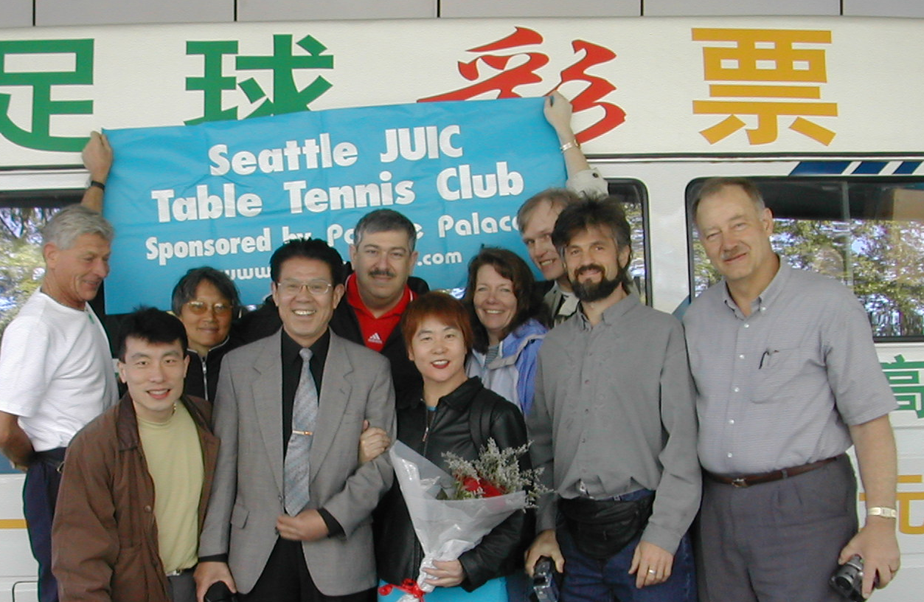
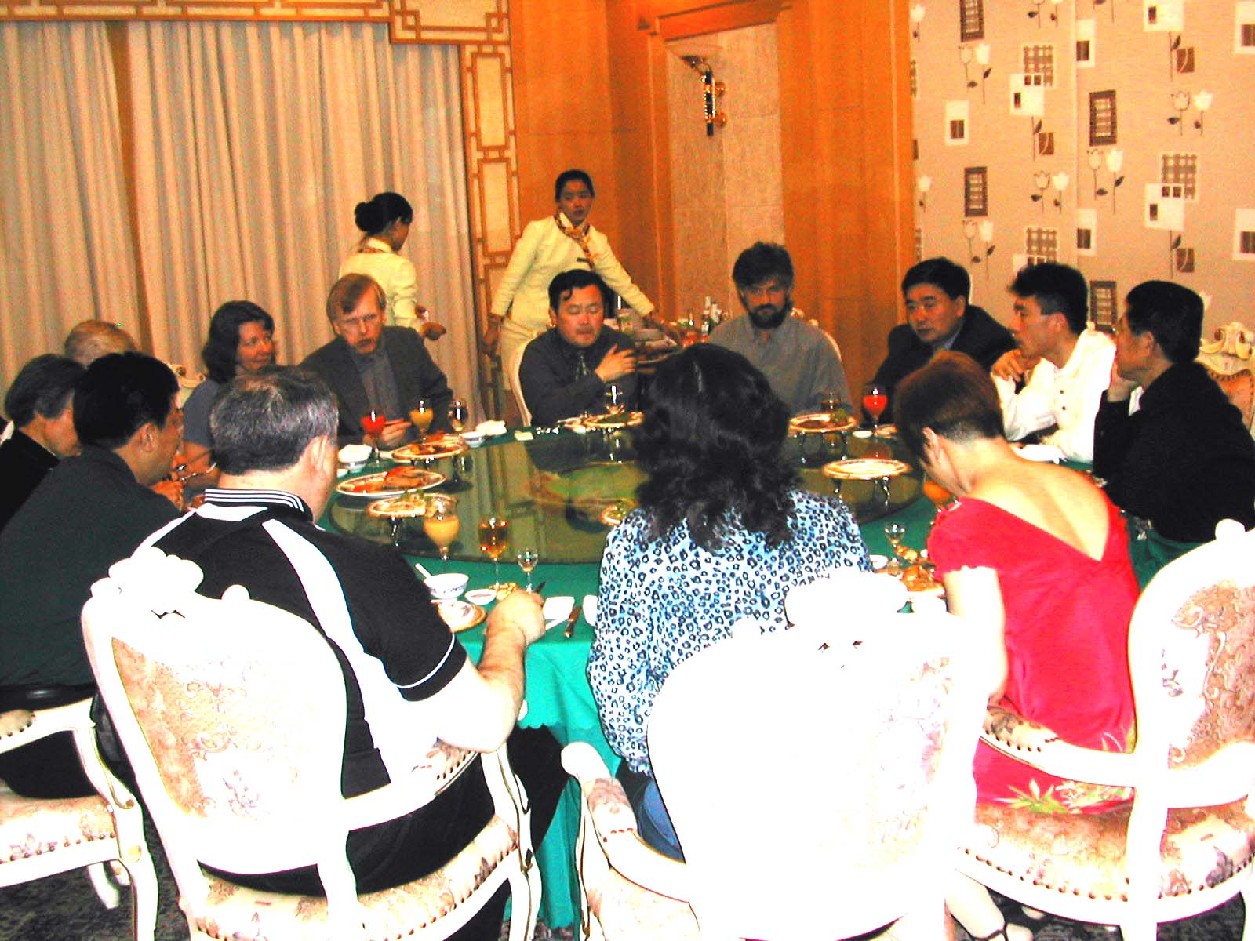
Breaking the ice at the welcome banquet with Zibo officials.
placed before him or her first. Wine, beer, or juice and tea were constantly being replenished so that we could toast each other one on one or for the entire group. Refusing to participate in toasts was considered bad manners. The Chinese thinking is that they don’t want to get uninhibited without your participation. Toasts occurred often during the meal. Dumplings were usually one of the last dishes of the meal. Of course, we all used chopsticks to eat and to serve ourselves from the lazy susan.
Walter Sanlenbro, Yong Fan, Helen, Guan Qingliang (Retired Sports Minister and Yong's former coach), Saul Weinstein, Crystel Chin, Carol Stanton, Ben Badnarz, Alex Voronin and Alex Sumeri.

After too much to eat and drink (too many toasts) we changed into our table tennis clothes and went to practice at a nearby sports facility were young professional players 16 years old and younger were waiting for us. Many of them probably had turned pro by the age of 12. The facility was on the top floor of a sports complex and had 50 or 60 tables in the hall. We were paired according to our USATT ratings, the young Chinese according to their strength. They were all very skilled players, but didn’t try to intimidate us. They were very patient with us. We only practiced that night without playing any matches. There was quit an audience of young players and adults watching the Americans. The young players practiced with us till about 9:00 P.M., when they had to get ready for bed.

The next morning (13th) after a Chinese breakfast buffet at the hotel, we visited a Zibo amateur table tennis club for a friendship match. The club was located on the top floor of a television studio. There was a huge banner welcoming us. Much to our surprise and delight, we were to play some of the same officials who had hosted us at the welcoming banquet last night. The amateurs were very good-need I say more? Much fun was had by all.

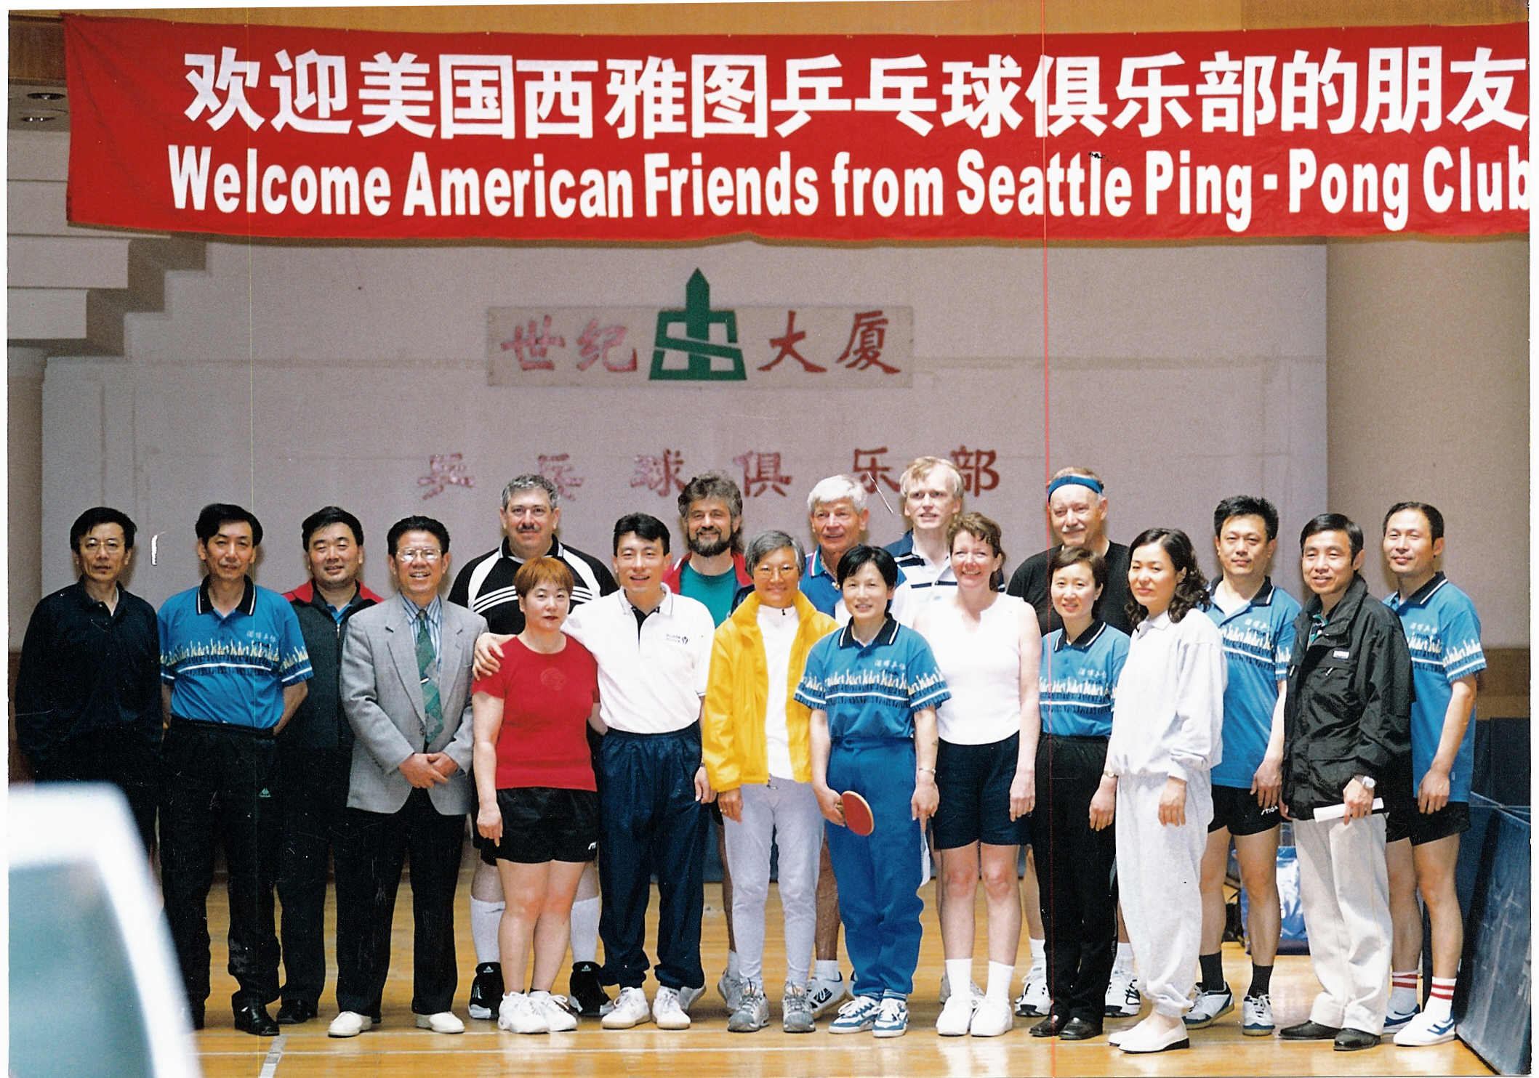
Posing with the Zibo Amateur Club.
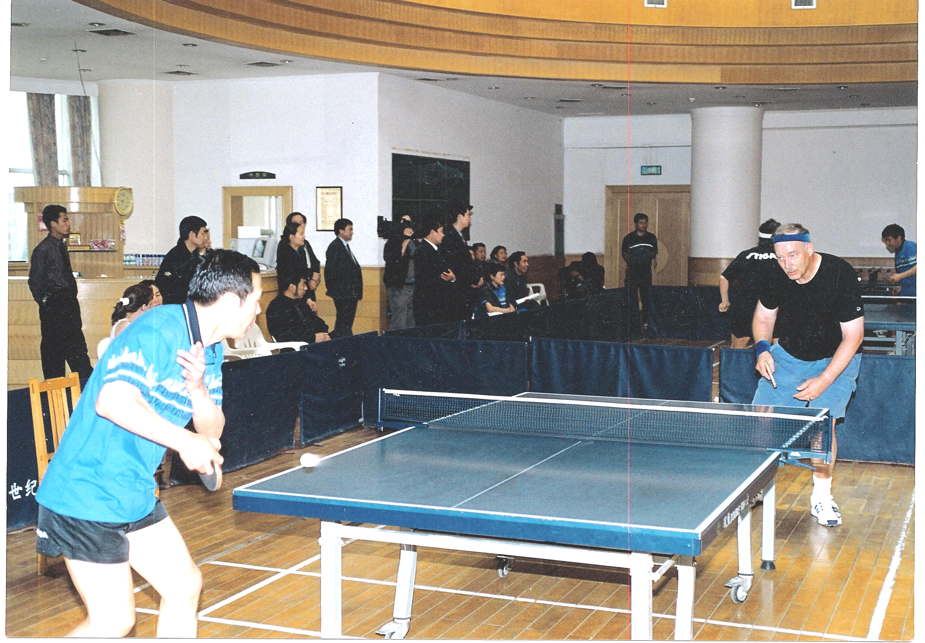
Alex Sumeri playing a Zibo club amateur.
We were not able to finish some of the matches as we had to meet a another banquet (lunch) schedule and an afternoon visit to a museum
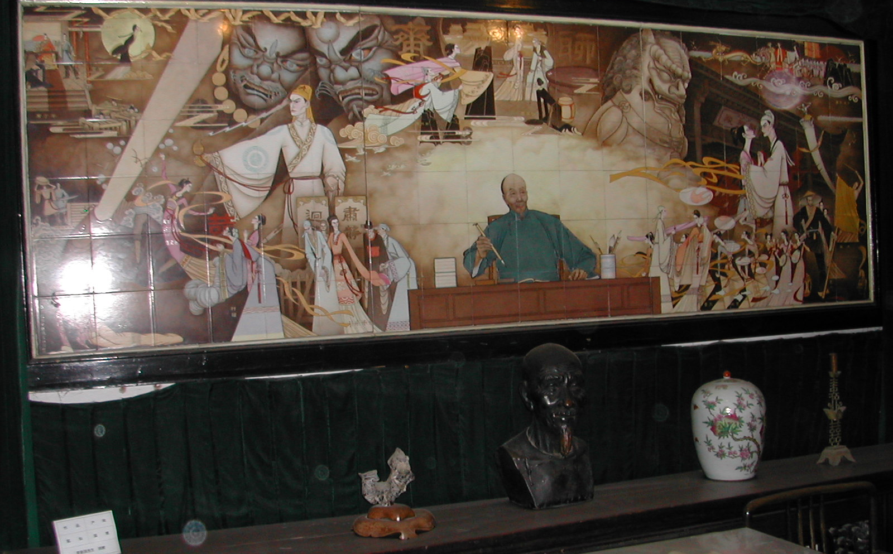
Ceramic mural of Pu Songling.
honoring a famous local writer of ghost stories and parables, Pu Songling,
who lived 1640-1715, during the Ming Dynasty. The Zibo Police Chief,
also an amateur photographer, had been taking pictures of all of our activities and distributing the photos. At the museum he took individual professional quality portraits of all of us. Many of the photos in this article were taken by him. Nice memories!

Dinner was another fantastic 35-dish affair at a seafood restaurant. We had lobster, crab, mussels, lax, shrimp, fish, and assorted vegetables. The platters were presented wonderfully as shown in the pictures below.

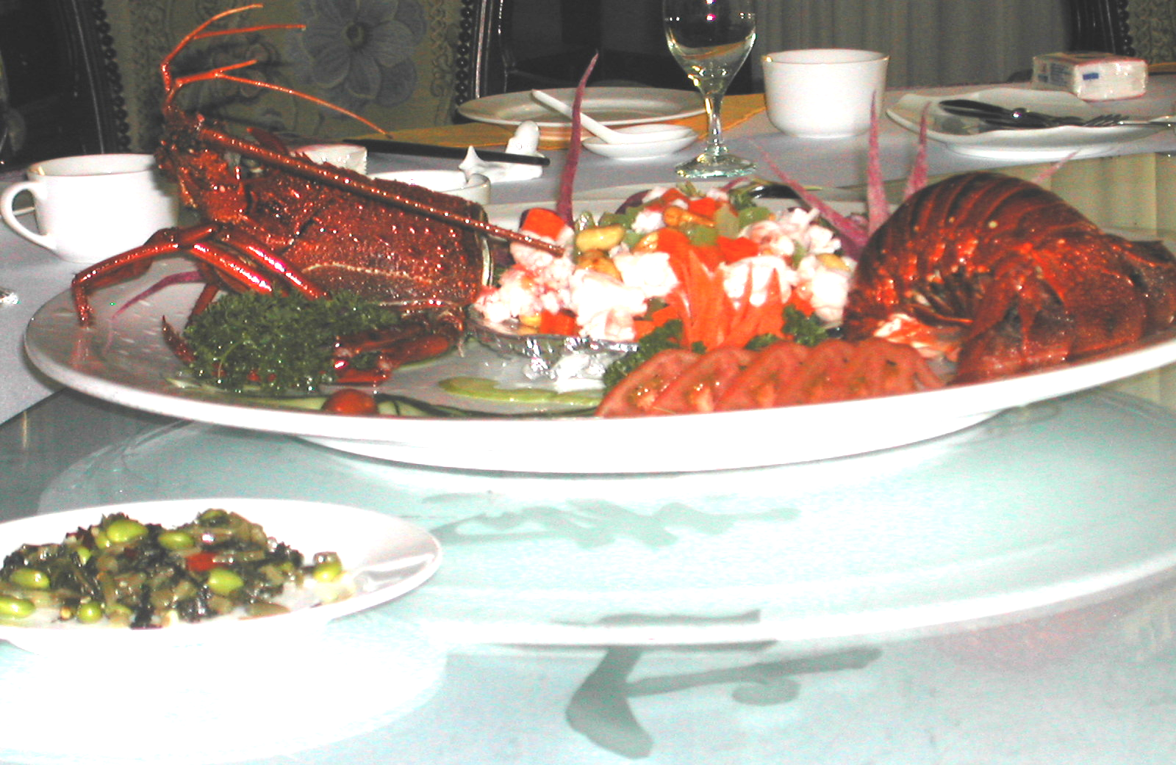
Lobster with a great presentation.
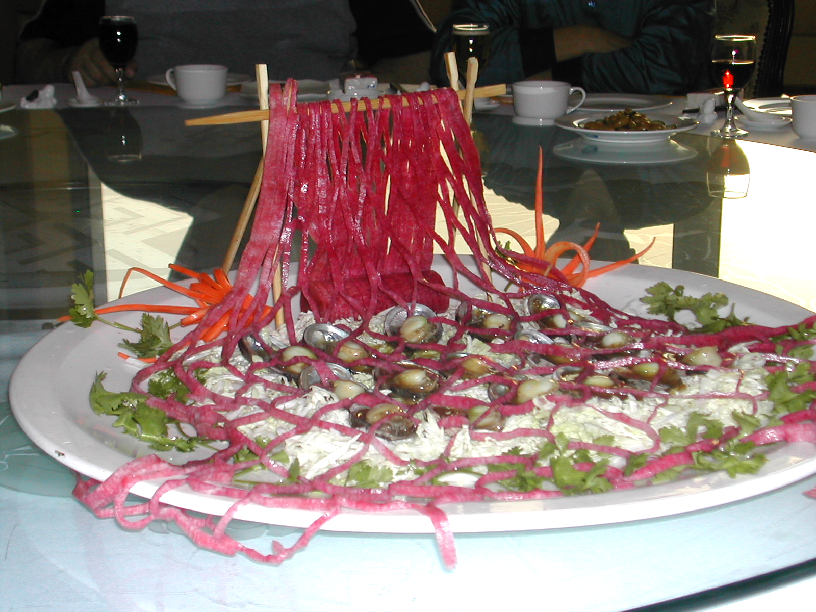
Mussels.
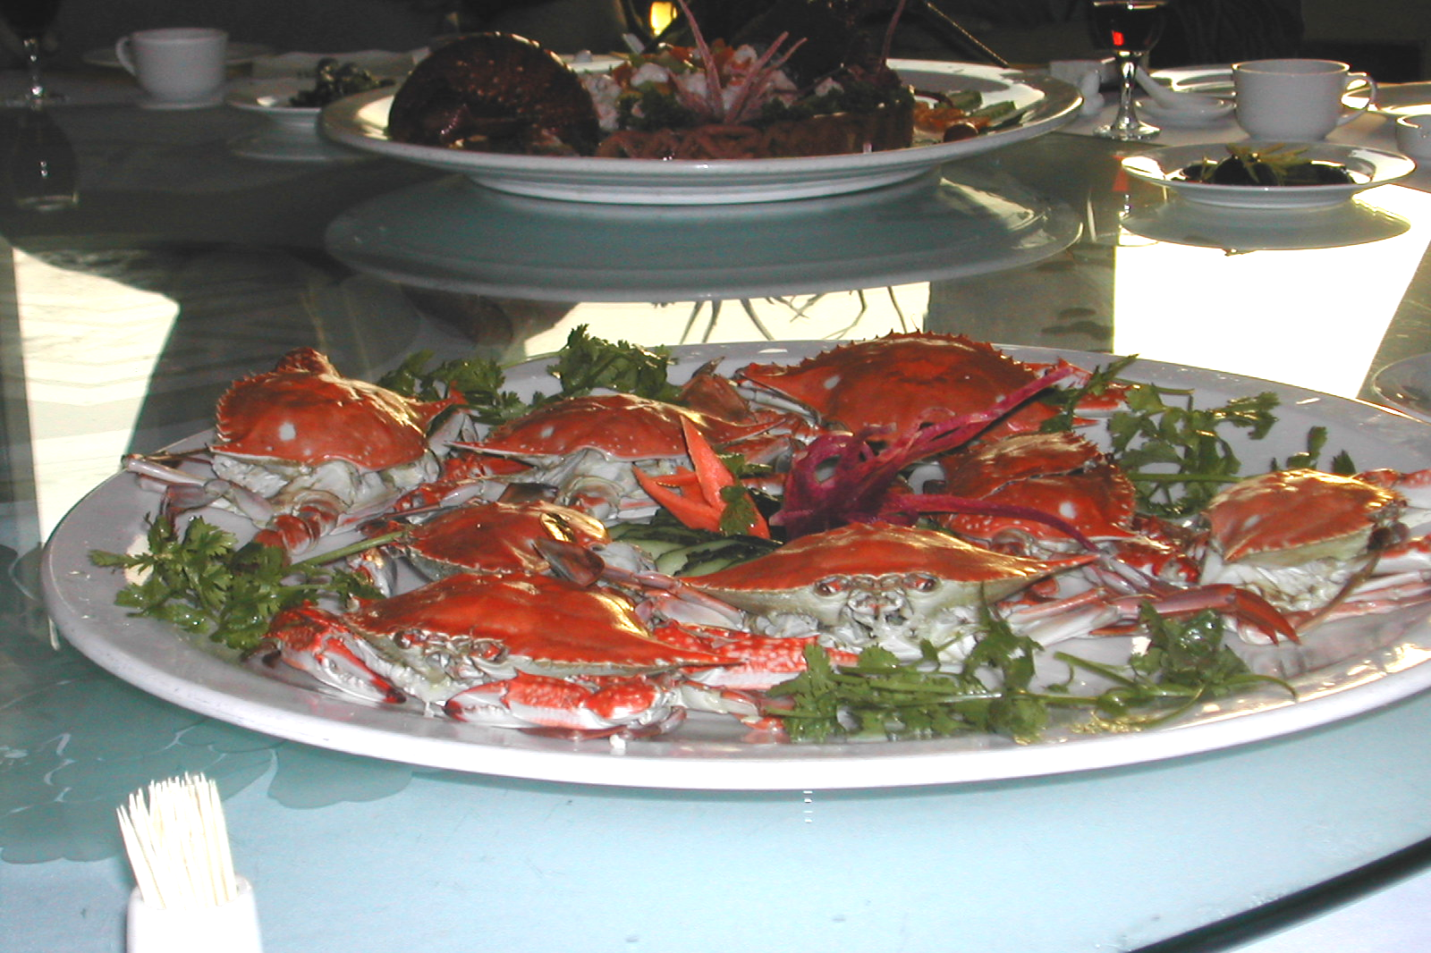
Crab.

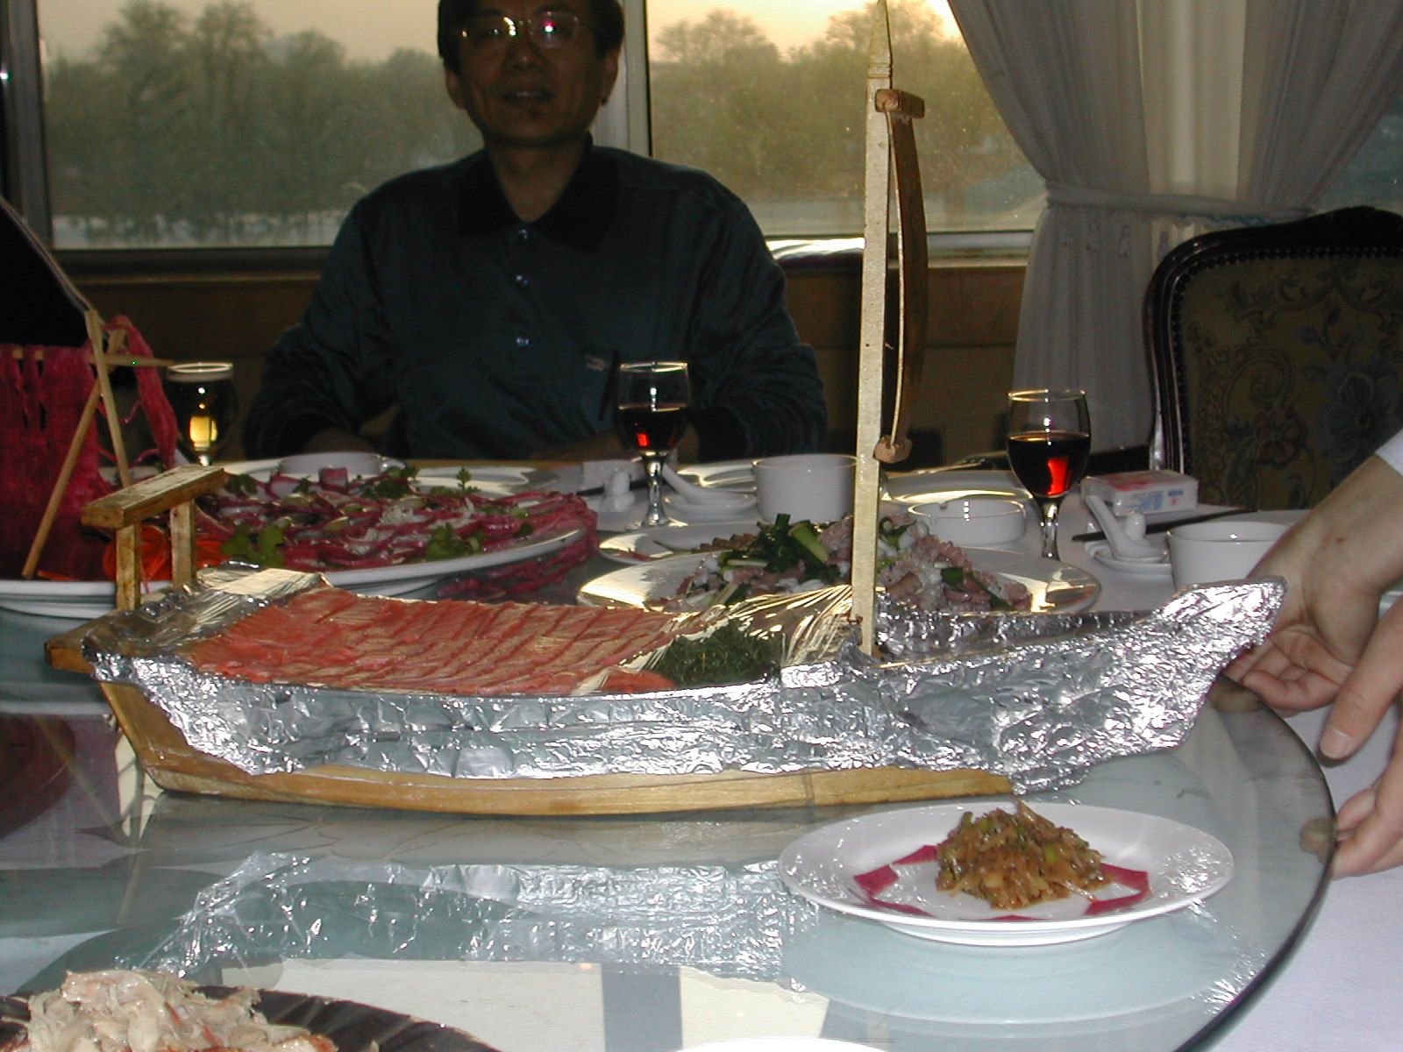
Lax boat.
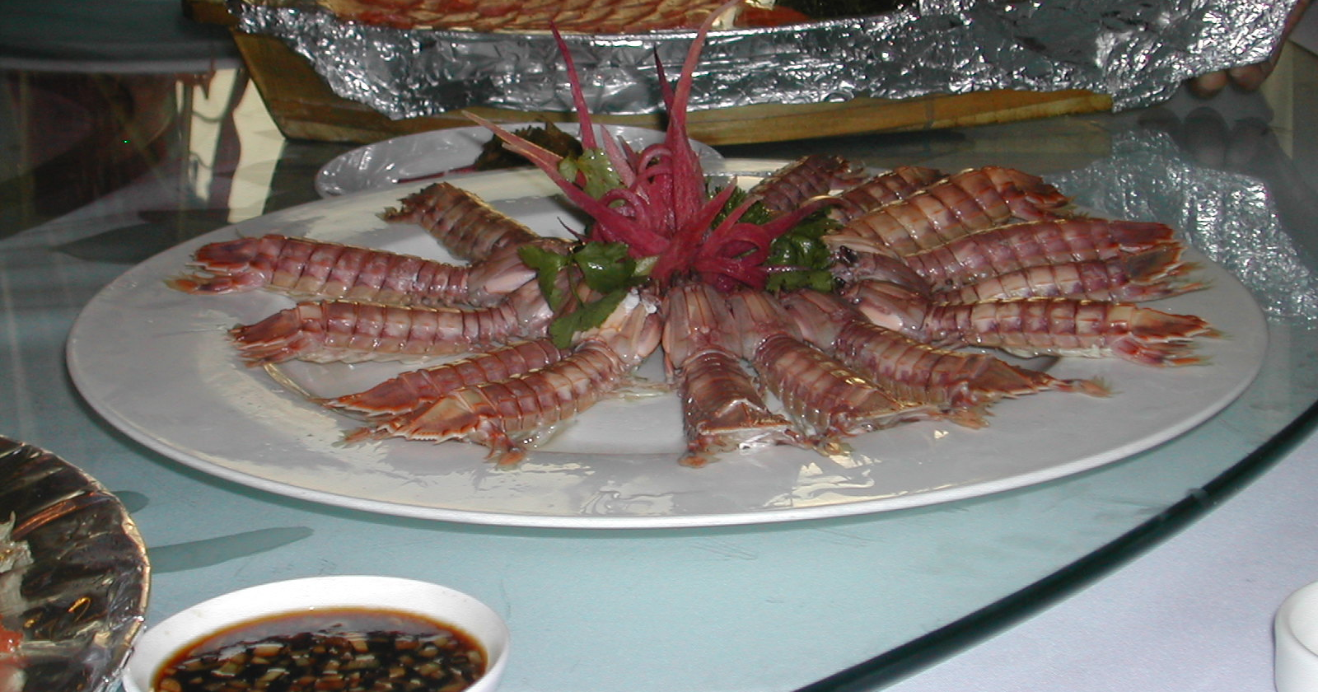
Shrimp that looked like centipedes.
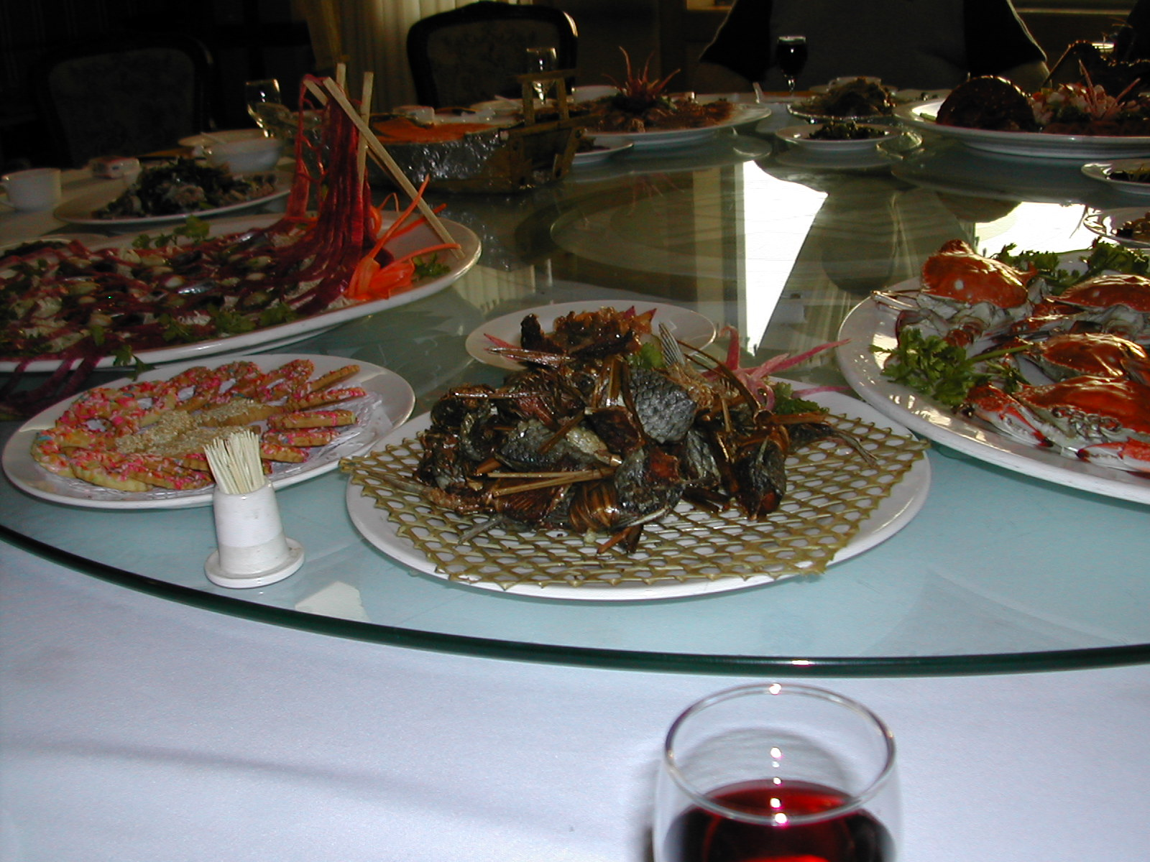
Assorted seafood dishes.
9-14. After breakfast at the hotel, we drove to a table tennis club located on the upper floor of the You Quan Simpson Hotel. The hotel offered a bowling alley and swimming pool. We played some enjoyable matches
with the amateur club even winning some. We hurried back to our hotel to shower and returned to the You Quan Simpson Hotel for lunch, which was hosted by industry officials. We had another fantastic banquet with endless dishes and, of course, many toasts. There even was a company translator.

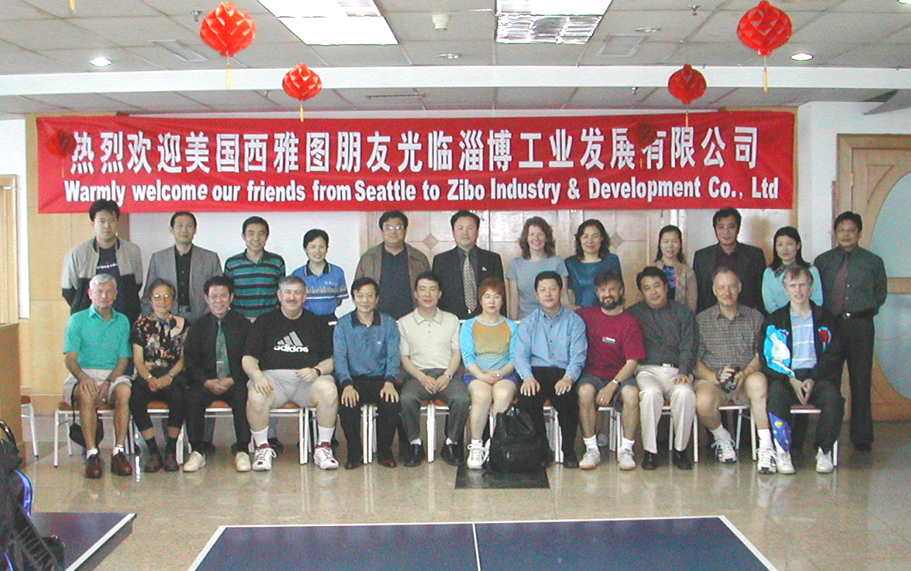
Amateur players and officials at the You Quan Simpson Hotel.

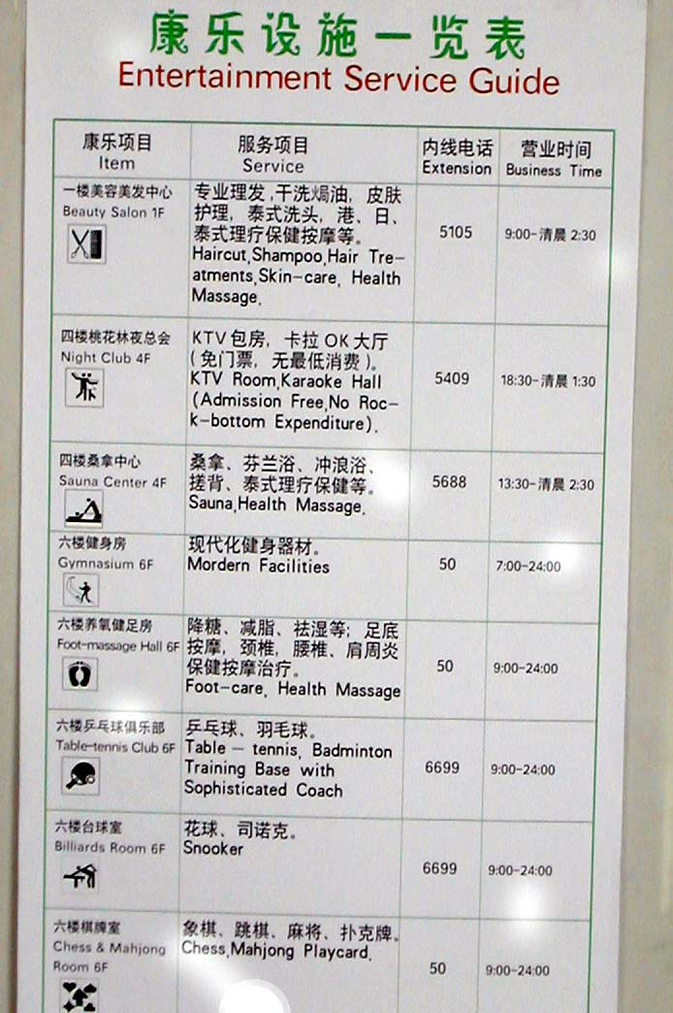
You Quan SimpsonHotel Entertainment Guide. Note the Table Tennis Club.
That afternoon we drove to a suburb of Zibo and visited Middle School No. 5 where Yong Fan had attended in 1981. The school has an excellent table tennis program. We were greeted by young girls dressed in the school’s training suits who presented each of us with a flower bouquet. We
were escorted to a lounge were we were formally welcomed by the 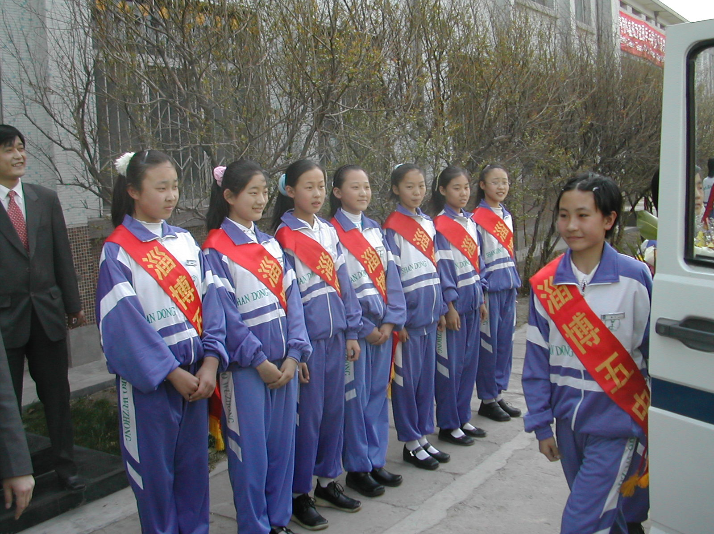
Middle School No. 5 girls greeted us with flowers.
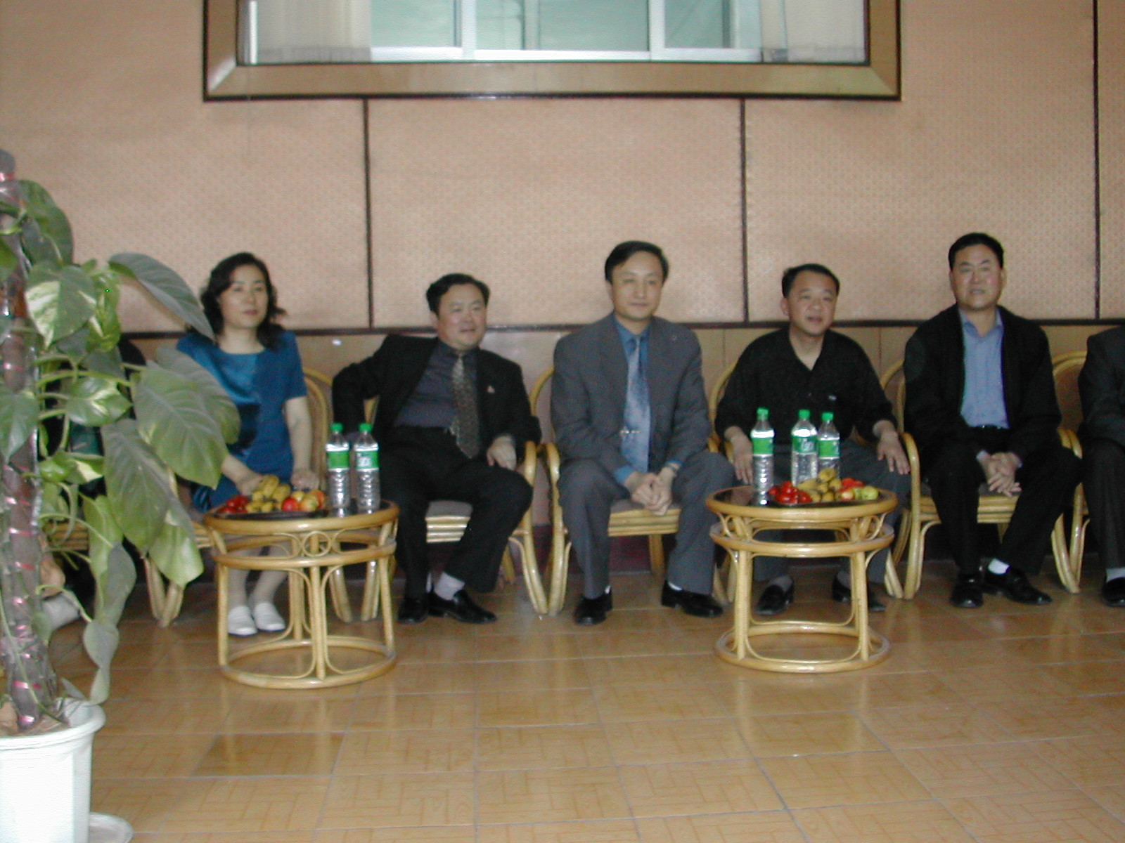
Sport and school officials (Principal in center).

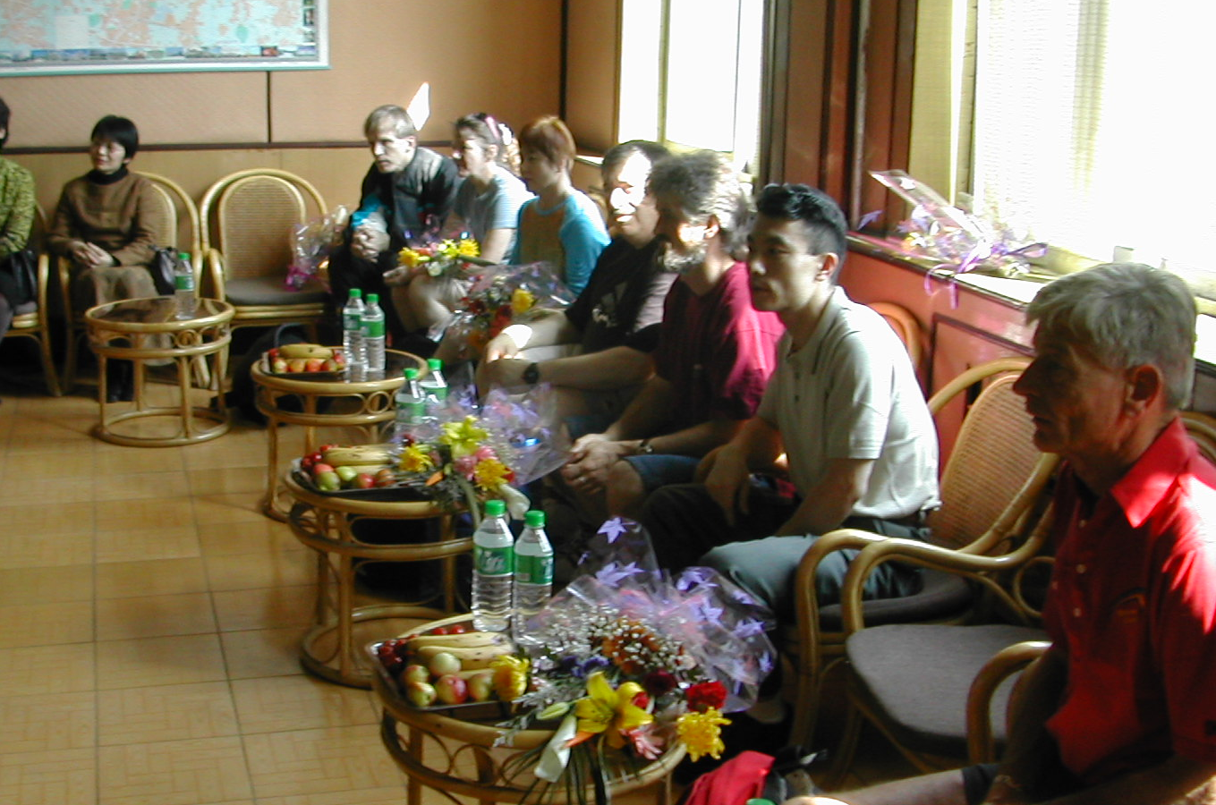
Being hosted by school officials at Middle School No. 5.

school officials. Fruit and drinks were provided. Welcoming speeches were exchanged. Then we toured the school. We visited a computer lab, popped into a couple of active classrooms, saw a room exhibiting student artwork and calligraphy (very impressive), and the school’s trophy and awards room. We saw concrete ping-pong tables in the schoolyard. Then we played our table tennis match. We each played matches against three students. I’m only aware of one win by our group. That evening there was another big dinner banquet with an overwhelming number of dishes hosted by the school officials
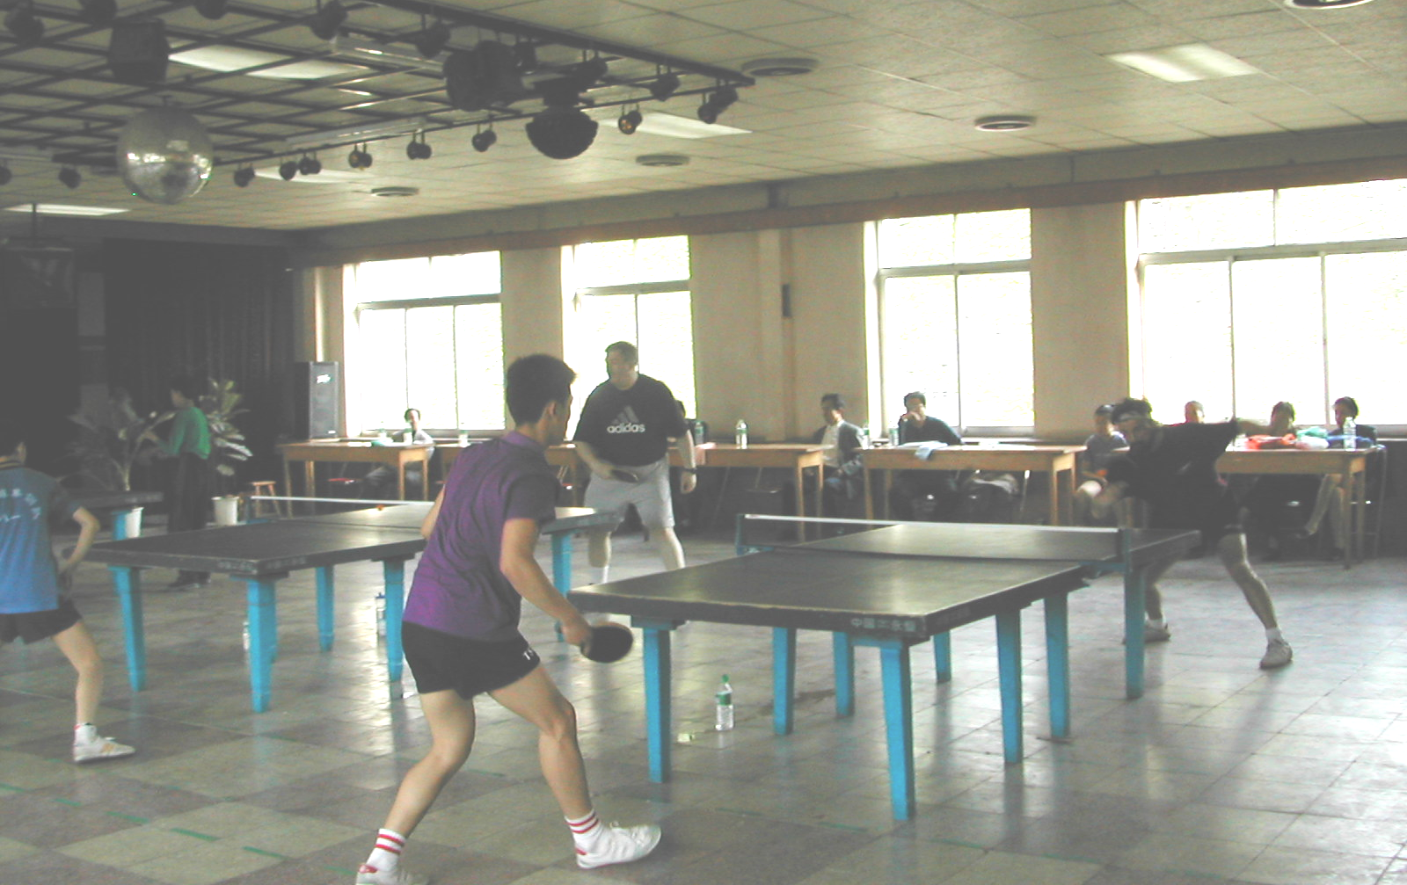
Alex Voronin and Saul Weinstein playing the students at Middle School No.5. Alex won a close match.

15th. In the morning we visited a small sporting goods store that handled table tennis supplies and purchased (bargained for) some nice Butterfly and Donic table tennis shirts for about $12 each. Others purchased shorts, training suits and balls by the gross. We then continued on our way to practice/play against the young professionals we met the first night.

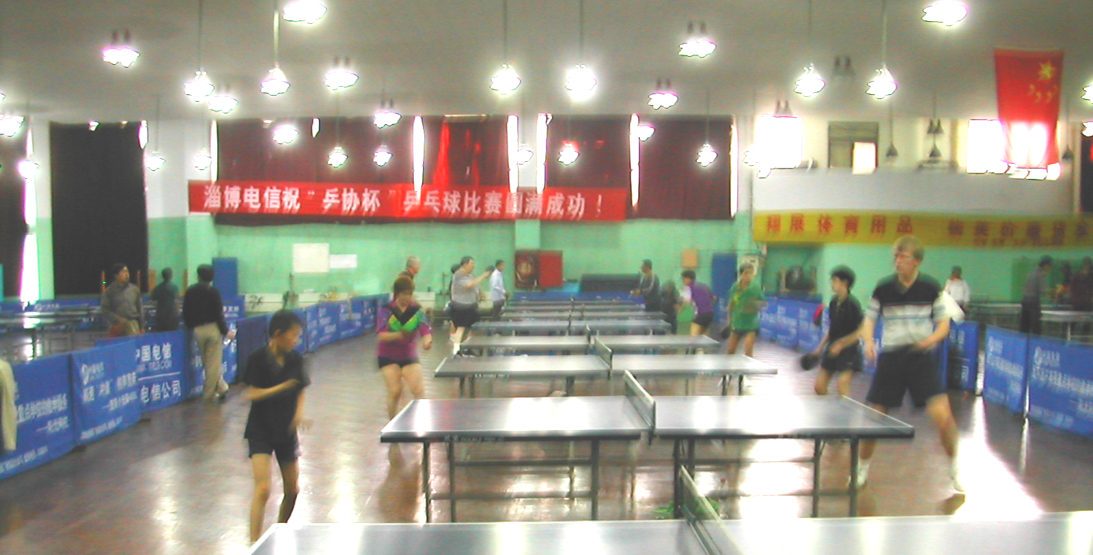
Playing with the young professionals.

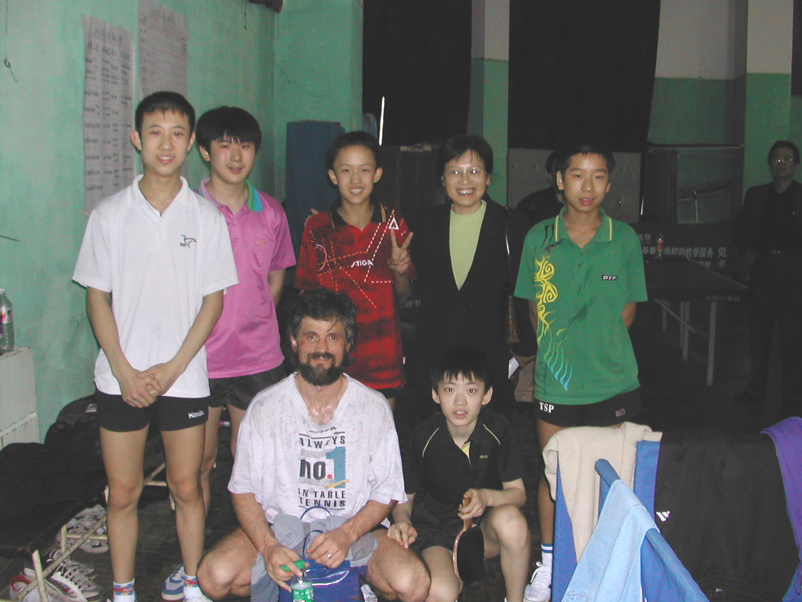
Alex Voronin with some of the young pros and the Table Tennis Minister of Zibo. The youngster behind Alex (showing the victory sign) was their best player. He had beaten Alex.
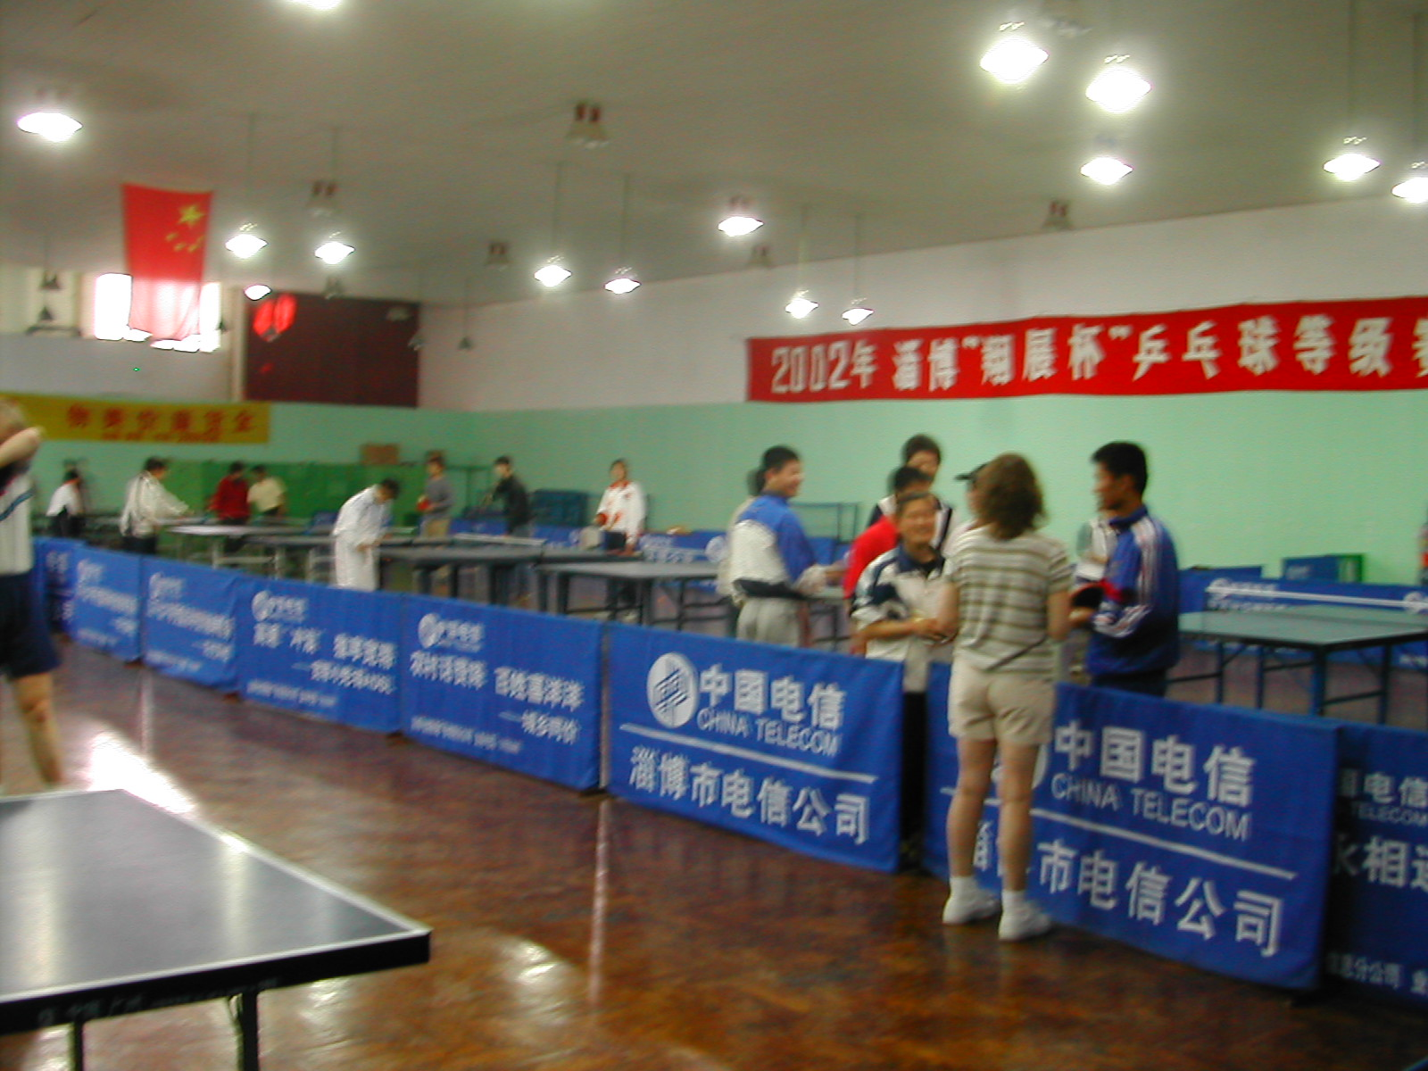
Carol Stanton with admirers where we played the young pros.
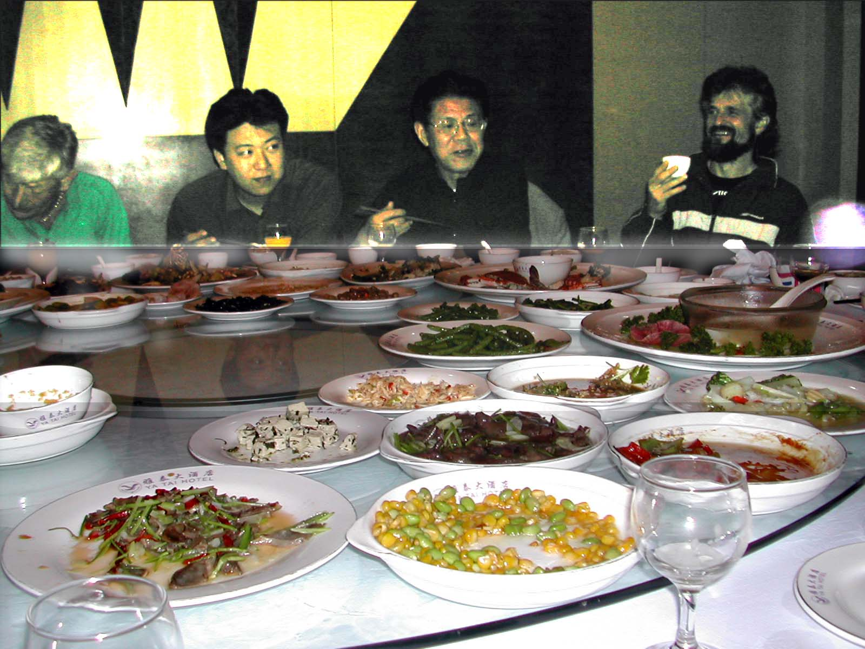
Alex Voronin toasting industry officials at lunch.
After another exquisite luncheon banquet we drove to an elementary school with a good table tennis program in a nearby suburb to tour the school and play a match. First, we toured a nearby 1200-pupil kindergarten. When we drove up to the gate of the kindergarten, there were a couple of welcome signs next to the gate. When we got off the bus we were met by the school officials and about 35 youngsters bouncing basketballs. Other children were doing a variety of other activities in the courtyard. Then we proceeded into another courtyard with even more children doing various coordination activities (rolling huge balls, some had plastic wheelbarrows, hula hoops, rolling tires, swinging, teeter tottering, jump roping, jumping in an enclosed trampoline about 15 feet in diameter, and many others activities). We then toured the kindergarten facility. We saw class crafts, clay modeling, a music rhythm class using bells (a la Carl Orf) accompanying traditional Chinese music. A class danced for us (partly gymnastic floor exercises). They were very good. We visited a computer lab with about 35 computers. We saw a room with a couple of shortened ping pong tables where the kids were in two lines with the instructors feeding them balls from buckets. The kindergarten kids were returning the balls with perfect strokes and the kids behind them were practicing the strokes in unison with the ones hitting the balls. We visited the school kitchen where seven cooks were preparing vegetables, dumplings and soup.

Then we walked to the elementary school where we were greeted by two welcoming signs in Chinese and English: “Congratulate China and America the Friendly Match of Table Tennis in our School” and “Welcome American Guests to Our School.” The school faculty was lined up inside the gate to greet us. All were wearing dark gray suits. There were 10 women and 5 men to greet us, plus the school administration. The school was fairly new with nice landscaping. We toured the school visiting two computer labs with a total of 48 computers and viewed student notebooks on display. They varied in contents. Generally, they contained drawings, cutout pictures, calligraphy with Chinese characters, and some colored drawings. We toured the school’s library-small by our standards, an art class, a room exhibiting the best of student art and Chinese script (probably poetry or famous quotes), a room exhibiting student crafts and a trophy/awards room.

The table tennis hall had 5 short-legged tables and 6 regulation-size tables with a low divider down the center of the room. Chairs lined the two long walls with spectators. The youngsters were excellent players and very focused. Group pictures were taken afterwards (I only have video).

We had another excellent dinner banquet with about 40 dishes plus drinks hosted by school officials at a local restaurant.

In the morning of the 16th we drove to Jinan for a match with a good amateur club. The facility was nice with overhead windows and held about 7 tables. Not sure if anyone in our group won a match. But, we had fun and learned some serves. A popular serve among the Chinese players we encountered is a short serve with a heavy corkscrew spin on the ball making it difficult to control when returning the serve. Another serve I observed and tried to learn is a medium/fast serve with a heavy sidespin on the ball which changes the lateral trajectory of the of the ball considerably. If you don’t watch the ball, you will miss it.

We ate a quick lunch at a company dining room. You could choose to eat in one of three dining rooms with Chinese, Korean or Japanese food. We ate at the Chinese dining room. The Shandong Province Sports Minister joined us for lunch.

On the way back to our hotel, we stopped at a large modern department store to do some shopping and just to look. There must have been about six or seven levels. You could purchase anything from furniture to motorcycles. In one area I saw about 5 or 6 big (about 1500 square feet) counters filled with watches of all price ranges-even Swiss watches. Except for the motorcycles, which were quite inexpensive, prices seemed comparable to the US. But Chinese wages are quite a bit less than in the US. Wages are highest in Beijing averaging 3000-4000 Yuan/mo ($375-$500/mo) and deteriorated the farther you got from Beijing.

In the afternoon we played amateurs at the Century Building Hotel in Zibo, where the Zibo City Mayor joined us for table tennis. Alex Voronin played the mayor and won. That evening we returned to the hotel where we played that afternoon for dinner. The room where we were hosted for the dinner banquet was exquisitely decorated-the fanciest dining room to date. The dishes also were very good.

17th. We boarded our bus and headed for the beautiful tourist city of Qingdao on the coast of the Yellow Sea. The 6-hour drive was primarily through flat agricultural land roads. Some hills appeared as we neared the coast. The tree-lined toll road was modern with at least four lanes. We crossed a large very modern twin a-frame pier cable stay bridge en-route. Very beautiful. Many of the larger bridges I saw in China were dramatically modern structures.

We checked into our four star hotel in the heart of the high-rise tourist hotel district, and went to dinner at a small family-run restaurant that specialized in the local seafood and partied. Lots of wine and beer flowed. This is the first time that I have seen a Russian out drunk. Yong Fan’s brother, Yi Min Fan, who organized most of the hosted events of our China itinerary was able to join us.

18th. We ate breakfast at a nearby restaurant that specialized in Western and Chinese food. Then we toured the City of Qingdao. The morning was spent at a huge seaside park that features outdoor sculptures and a nice time rocky beach where one can explore sea life. We had a wonderful time at the beach park. We saw a bride and groom in their wedding clothes having pictures taken with friends at the park. This seems to be common in China as I saw it in my later tour at a Guilin park. A famous Chinese export beer is brewed in Qingdao. The name and picture on the label are Qingdao and a tower that is the symbol of the city. We visited the tower. After a little shopping and walking along another city waterfront park it was time to start our trip back to Zibo.
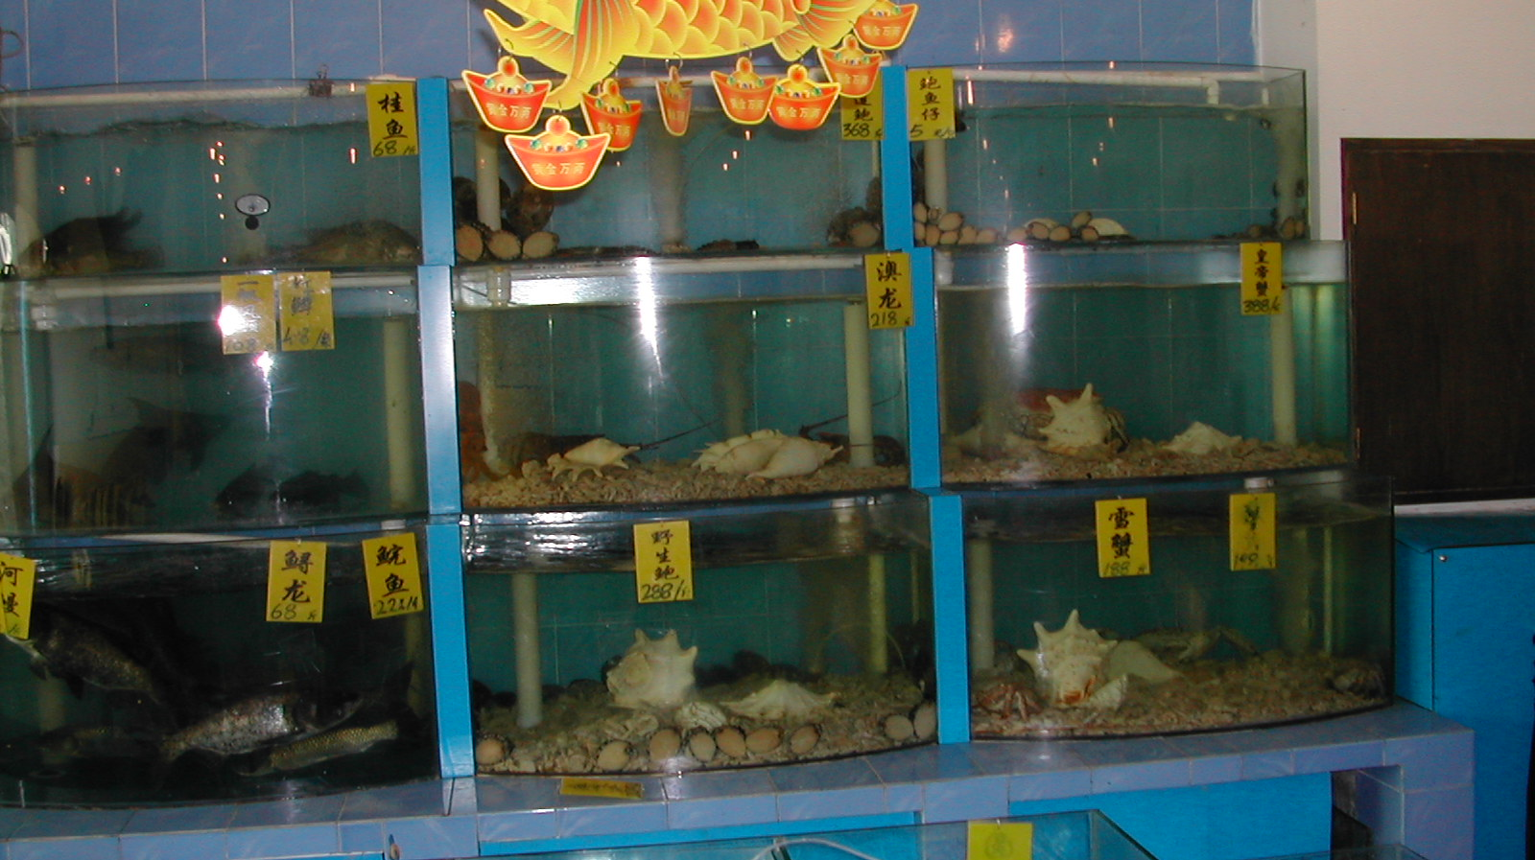
You can select your fresh dinner at the Qingdao seafood restaurant we went to.
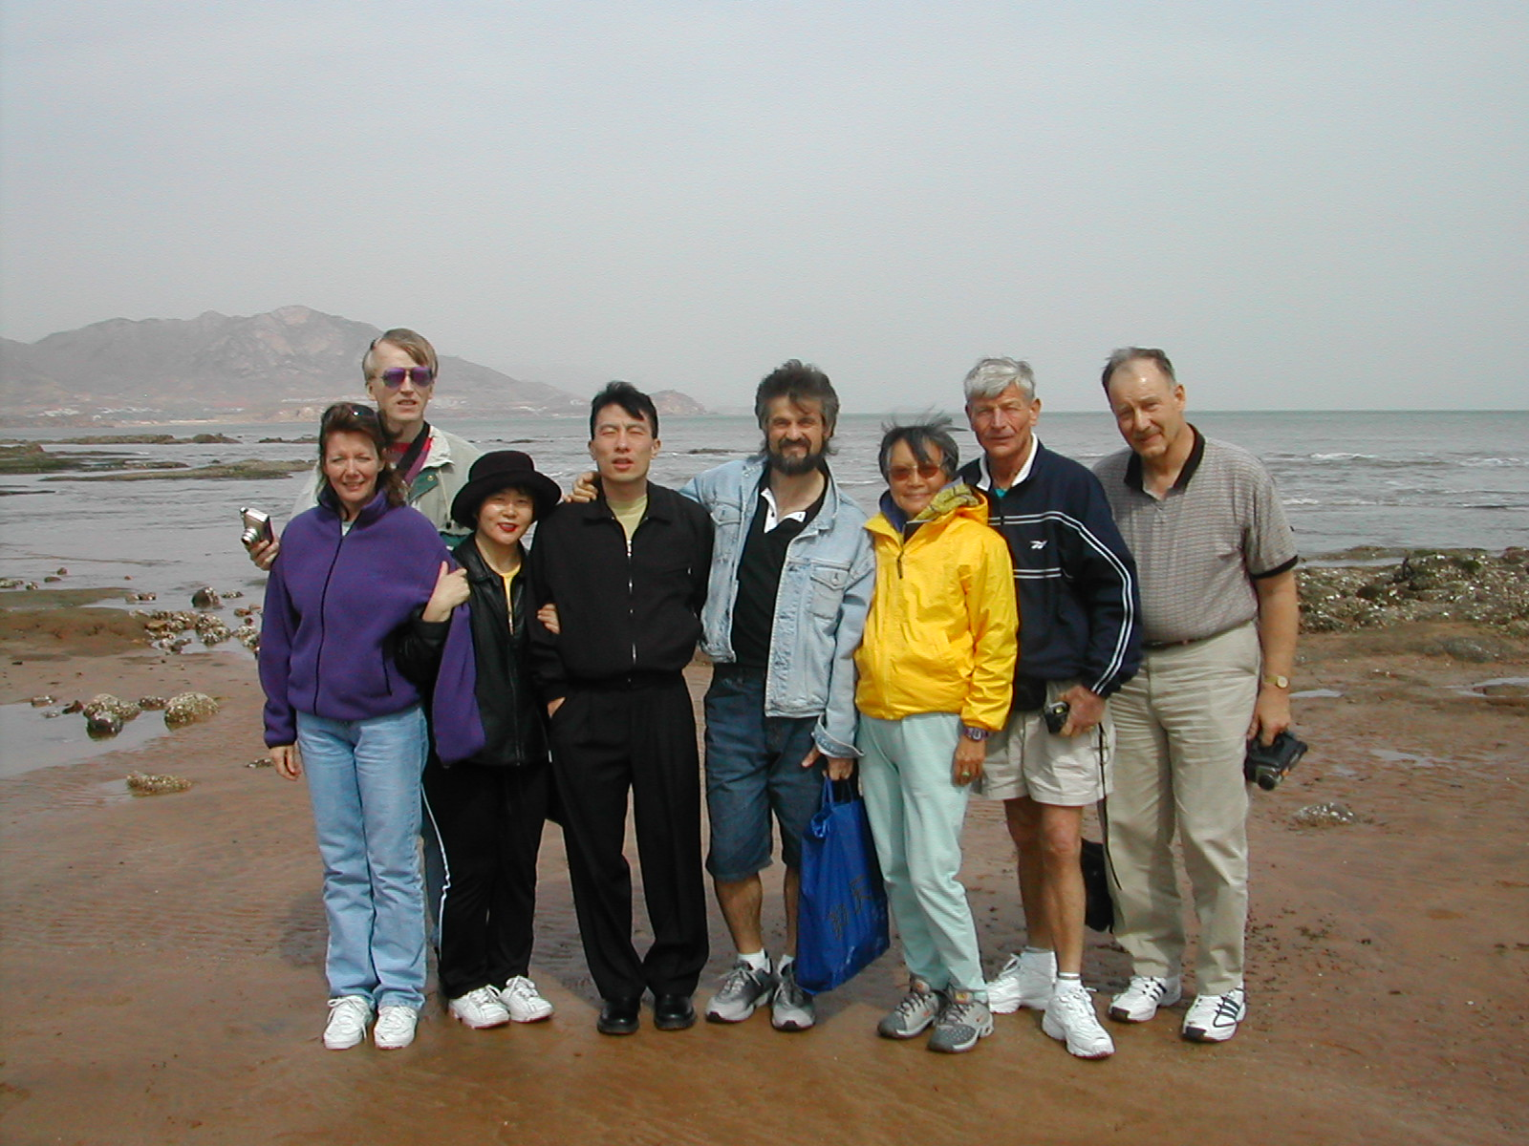
On the beach at Qingdao.

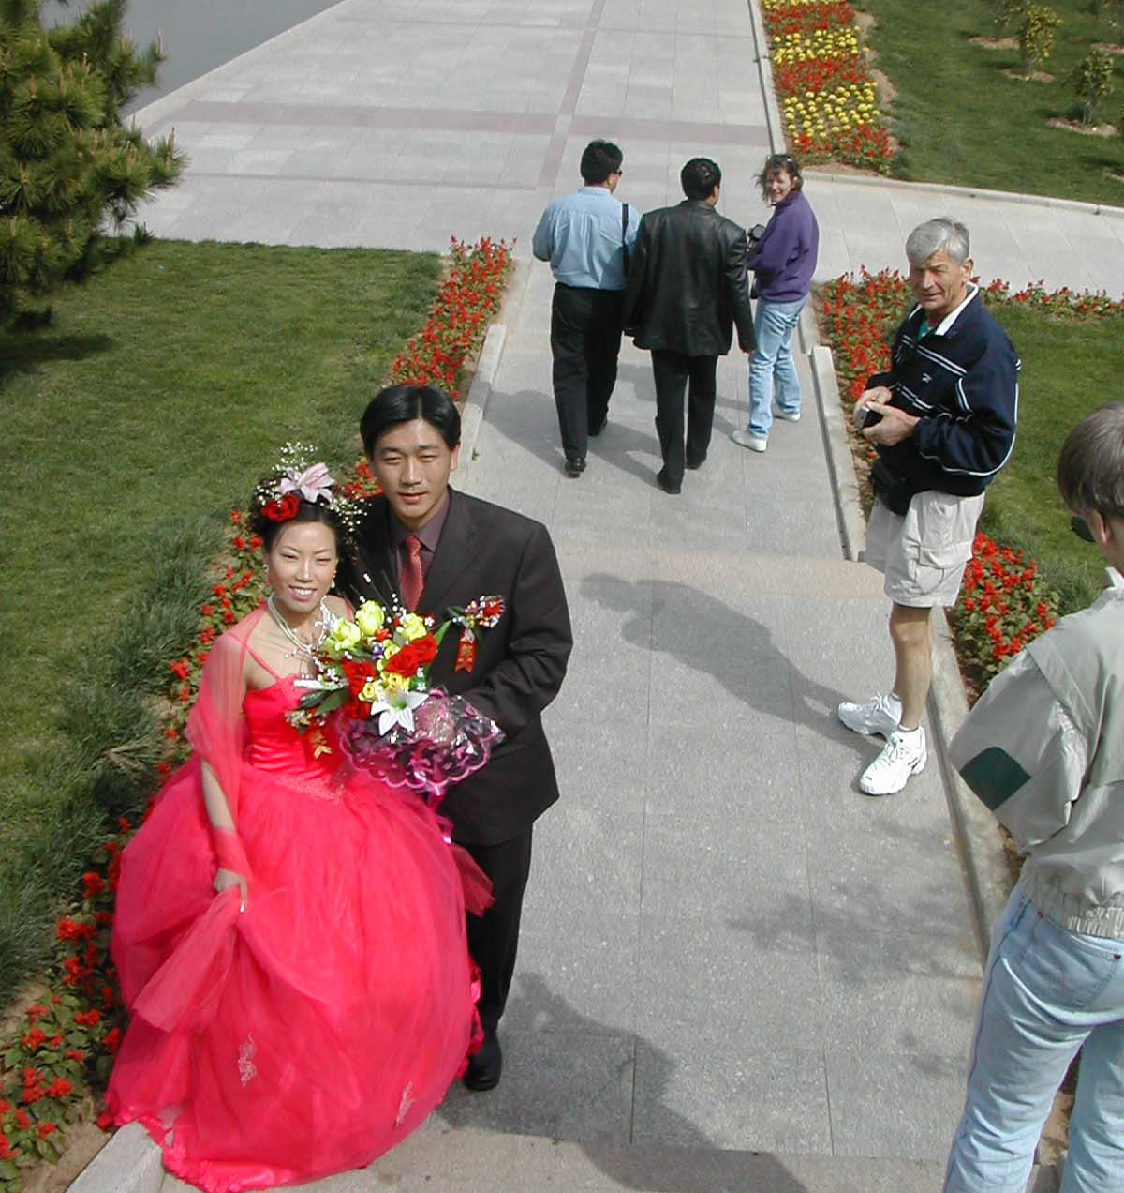
Bride and Groom strolling in the beach park at Qindao.
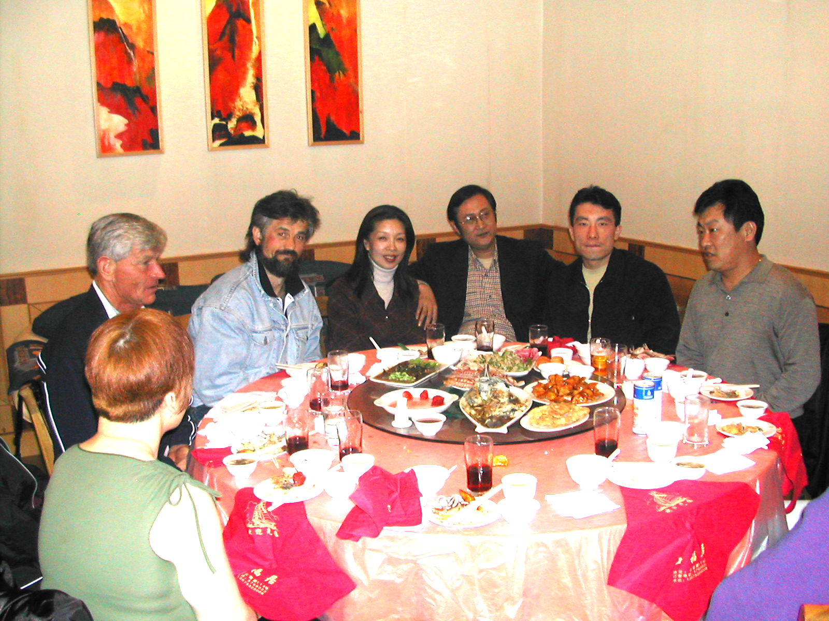
Partying at dinner in Qingdao. Crystel Chin, Walter Salenbro, Alex Voronin, business friends of Yong’s brother, Yong Fan, and Yi Min Fan (Yong’s brother).

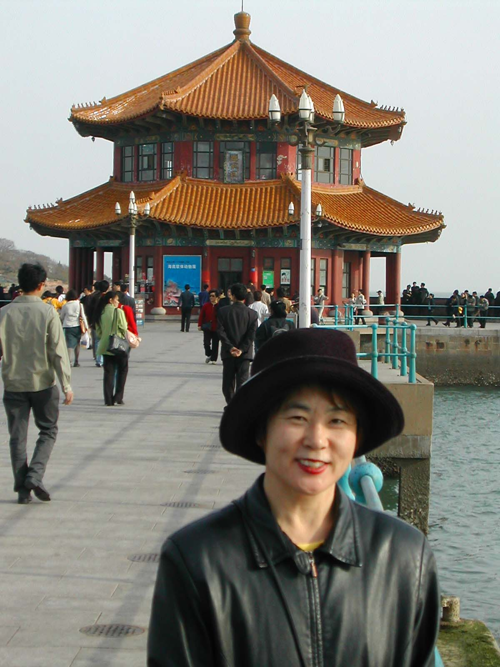
Crystel Chin in front of the symbol of Qingdao.

That night we had a farewell dinner banquet. Aside from all the photos we received from the Police Chief, we received glass globes that had been hand painted on the inside, through a small hole in the bottom. Crystal collector bottles with hand painted pictures on the inside are also well known in China.

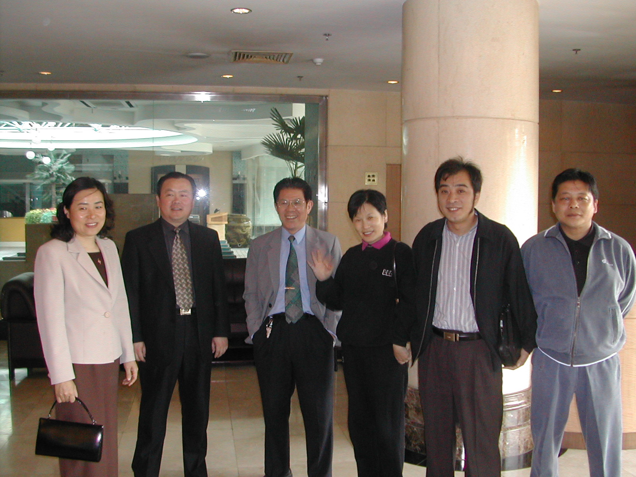
Zibo sports officials seeing us off.

19th. Sports officials from Zibo saw us off for our trip back to Beijing. The retired Zibo Sports Minister gave me his wristwatch. It has a paddle and the initials of the Shandong Table Tennis Association on the face. What a wonderful reminder of my new friends in China to take home with me.

The trip back to Beijing took about 12 hours. Our driver decided to drive on a non-toll road and we got caught in the worst traffic jam you can imagine due to a highway and bridge construction project.

We finally arrived in Beijing and decided to stay at the same airport hotel we had stayed the first time.

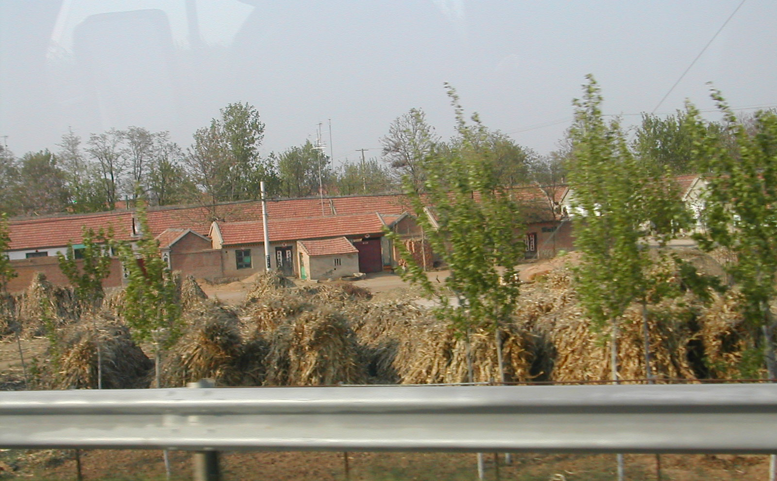A typical farm compound.

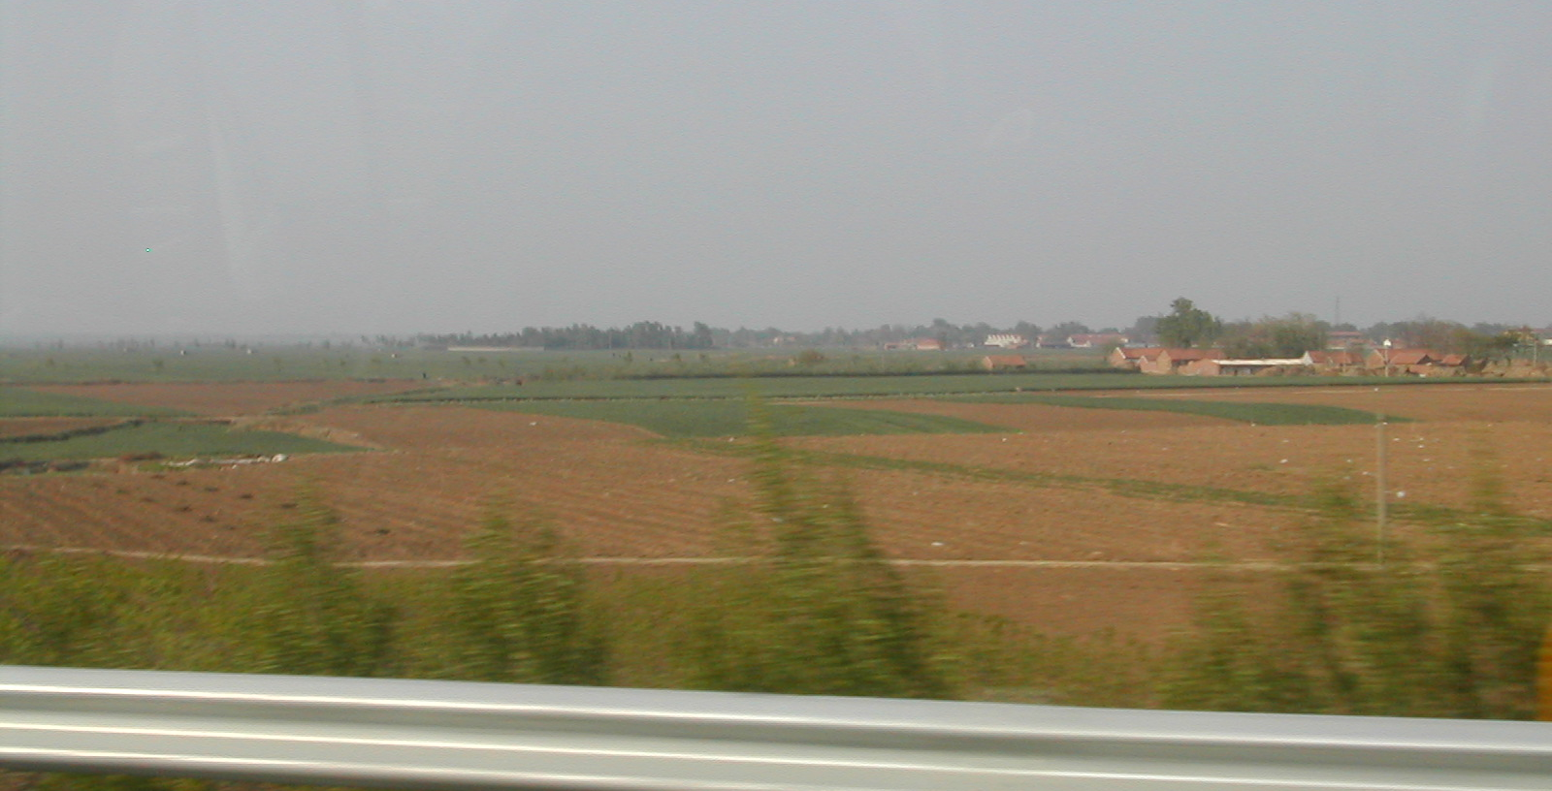
Flower and vegetable fields with a farm village in the distance.
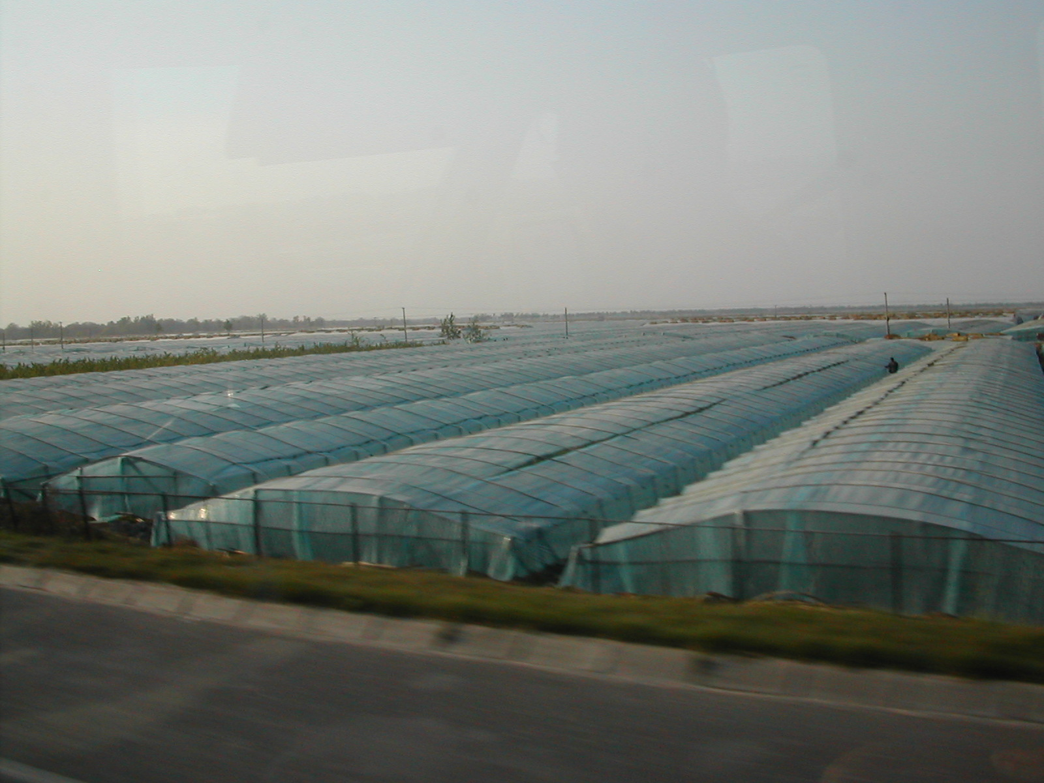
Typical greenhouses for growing vegetables. Some have rolled covers to protect against excessive sun.
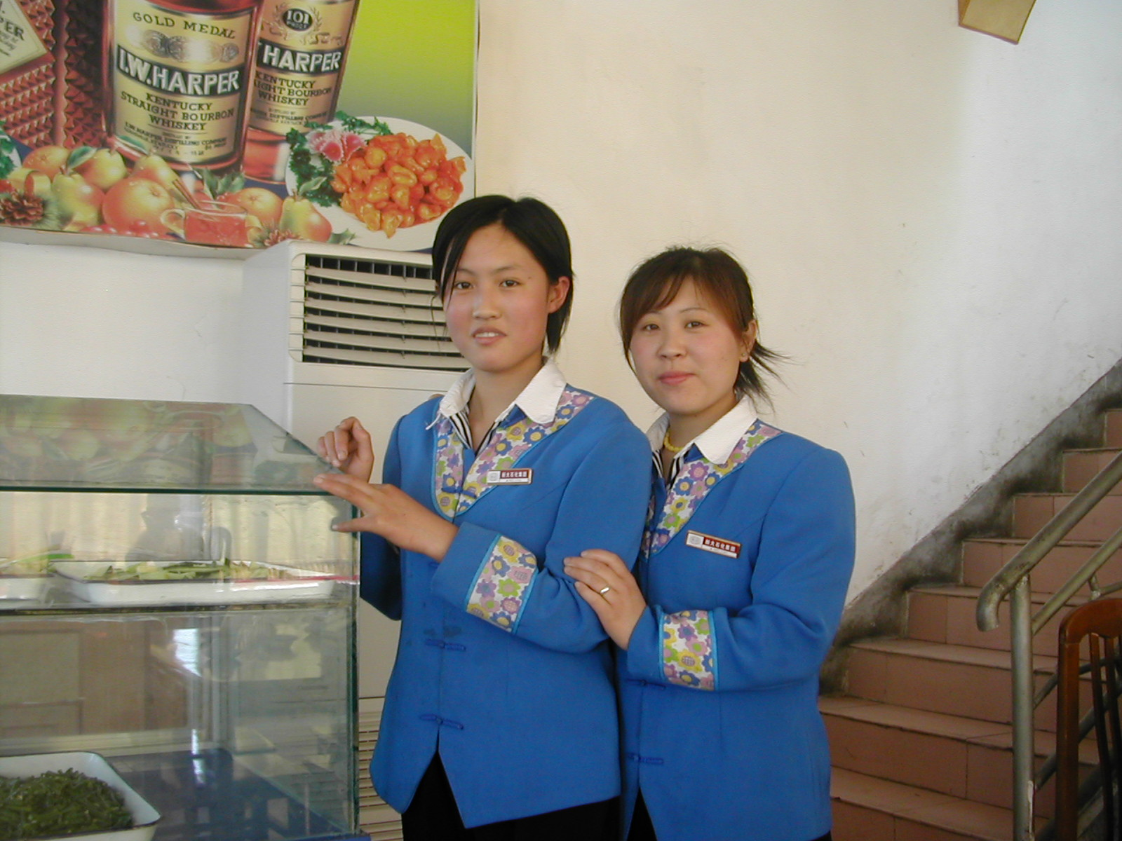
Young service girls at a highway gas station/shop.
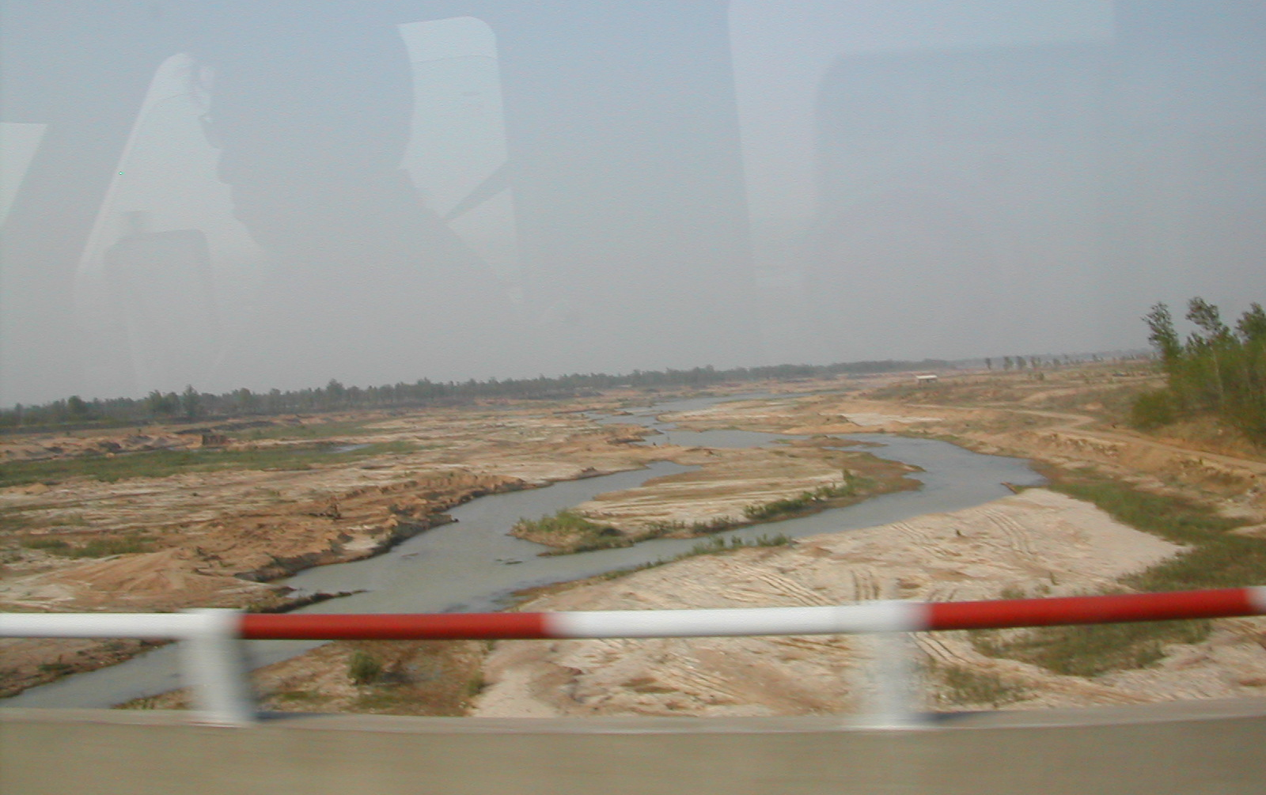
Crossing river or floodway. Floods are still a problem in China.
20th. Today we visited Tiananmen Square, the Forbidden City and the Summer Palace in Beijing. There was a huge line surrounding the building housing Mao’s preserved remains. It seemed like there were about 10,000 people milling around the 440,000 square meter Tiananmen Square-the largest one in the world. Vendors were selling tourist books, Olympics 2008 caps, postcards, etc.-all were looking for a US dollar. Tour guides with pendants were leading their tour groups. Our guide met us at the square and remained with us through the 21st. He was a well-educated middle-aged man with a college degree in geology. He had been caught up in Mao’s cultural revolution and sent to Mongolia to work on a farm. How sad. About 10 years of his life were wasted. He married late and has one child. The one child rule is very much enforced in China with few exceptions. If a couple has a daughter, they can try for a son. If that fails, they are allowed no more children. There are exceptions for deformed babies as well. There are stiff taxes for violators.
A Tang Dynasty poet wrote a line about the royal palace of his time, which says, "Without seeing the magnificence of the royal palace, one can never sense the dignity of the emperor." It served as the seat of imperial power during the Ming and Qing dynasties (1368-1911).

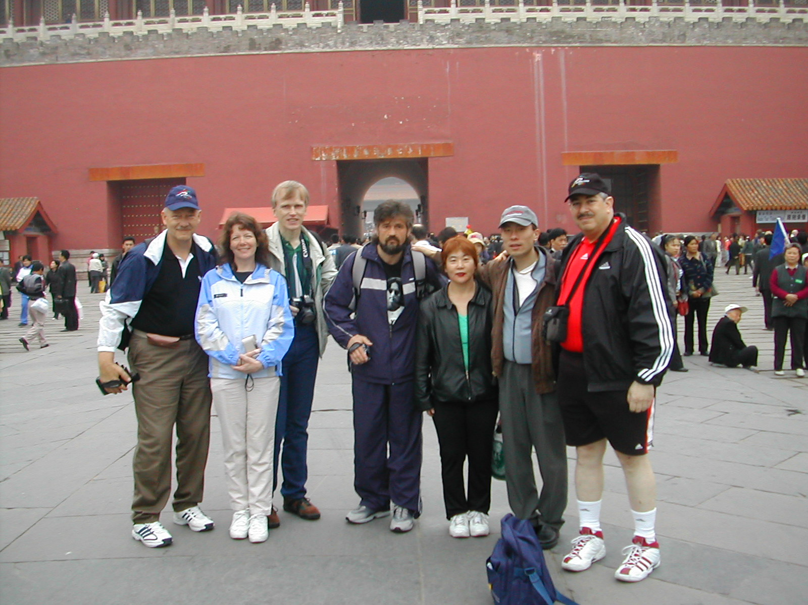
Our group standing in Tiananmen Square adjacent to an entrance to the Forbidden City.
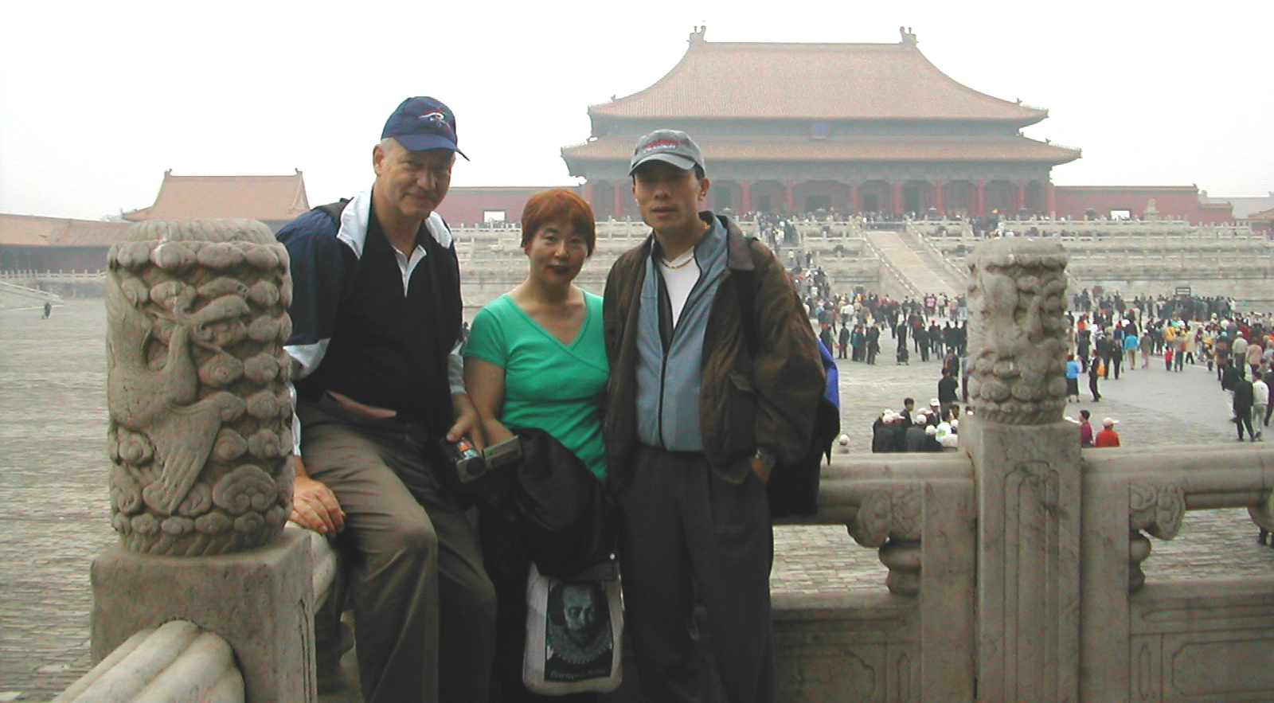
Alex, Crystel and Yong inside the Forbidden City.
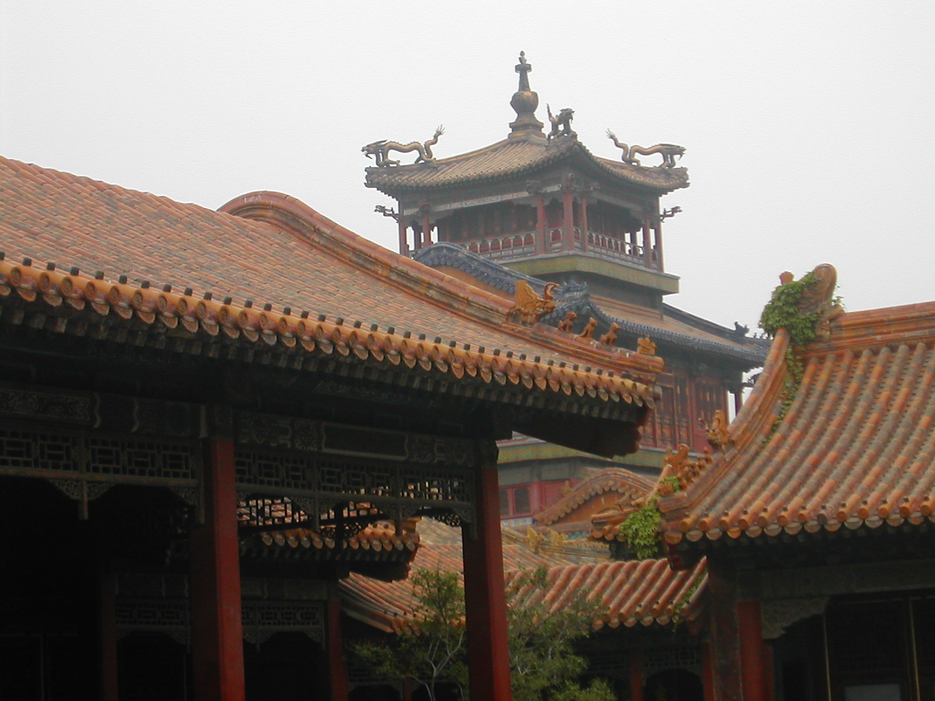
A corner tower inside the Forbidden City.
Next, we visited the beautiful Summer Palace, located adjacent to Kunming Lake. The grounds were extensive. On the grounds of the Summer Palace we were approached by an art student to visit an exhibit by the students and their professor. The art was beautiful and a lot less than in the State stores (i.e. at the Forbidden City-even with heavy bargaining). The students were raising money for a trip to Dortmund, Germany. Several paintings were bought here.

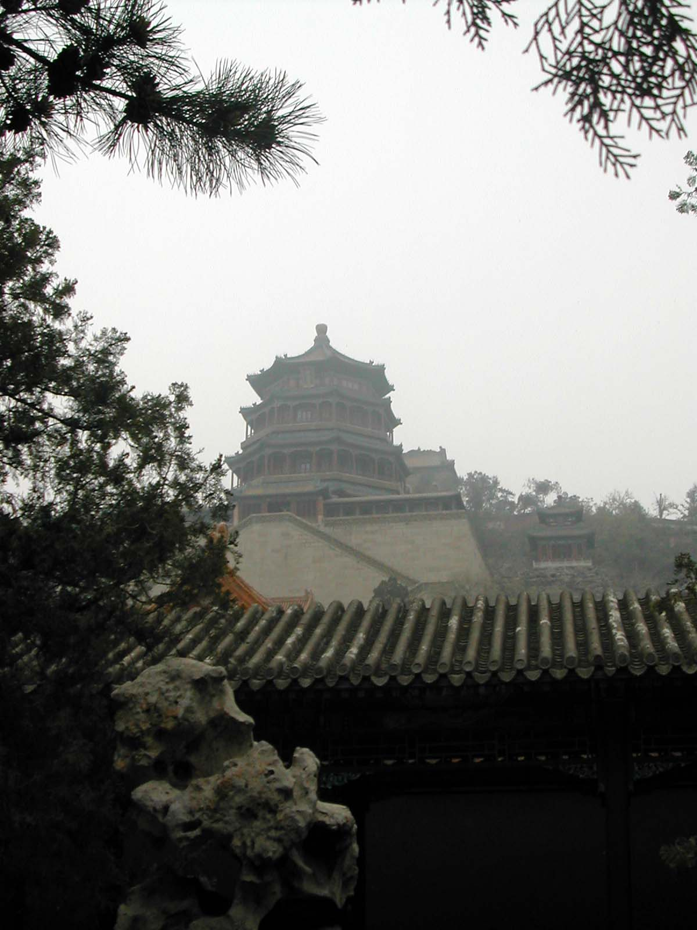
The 21-meter high Foxiang Pavilion overlooking the Summer Palace.

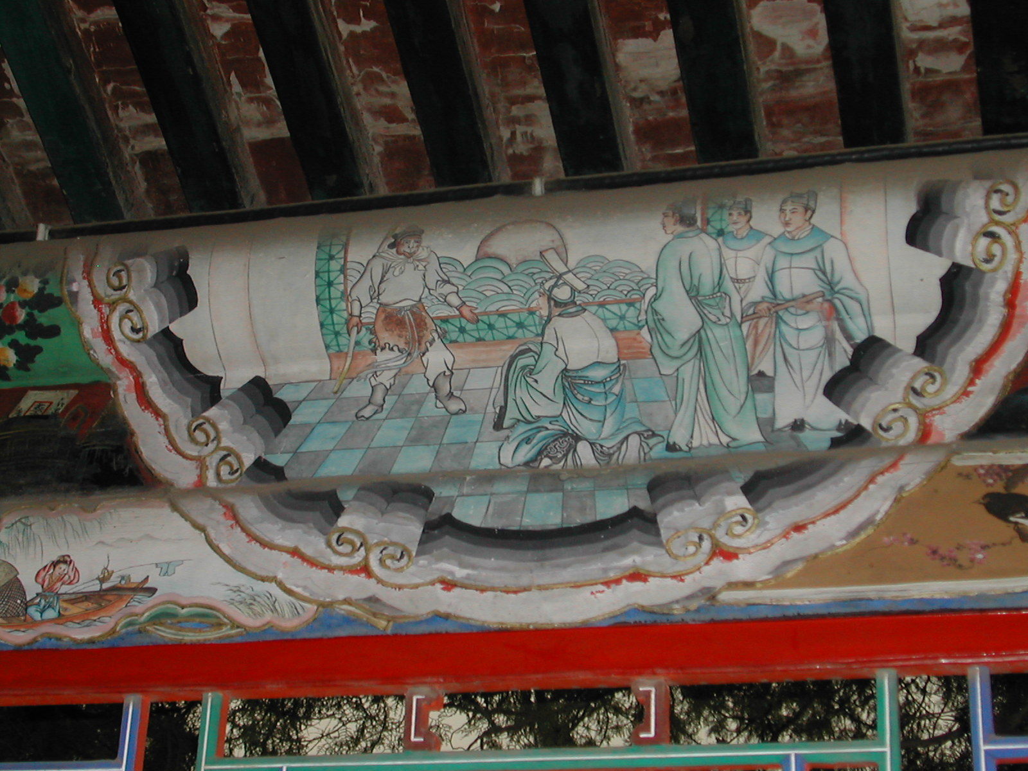
One of over 8000 small paintings decorating a famous 728-meter-long corridor on the grounds of the Summer Palace.

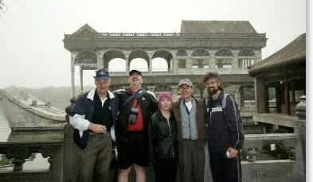
Alex, Saul, Crystel, Yong and Alex in front of the36-meter-long Marble Boat at the Summer Palace. It is immovable and symbolizes the steadfast rule of the Qing Dynasty.
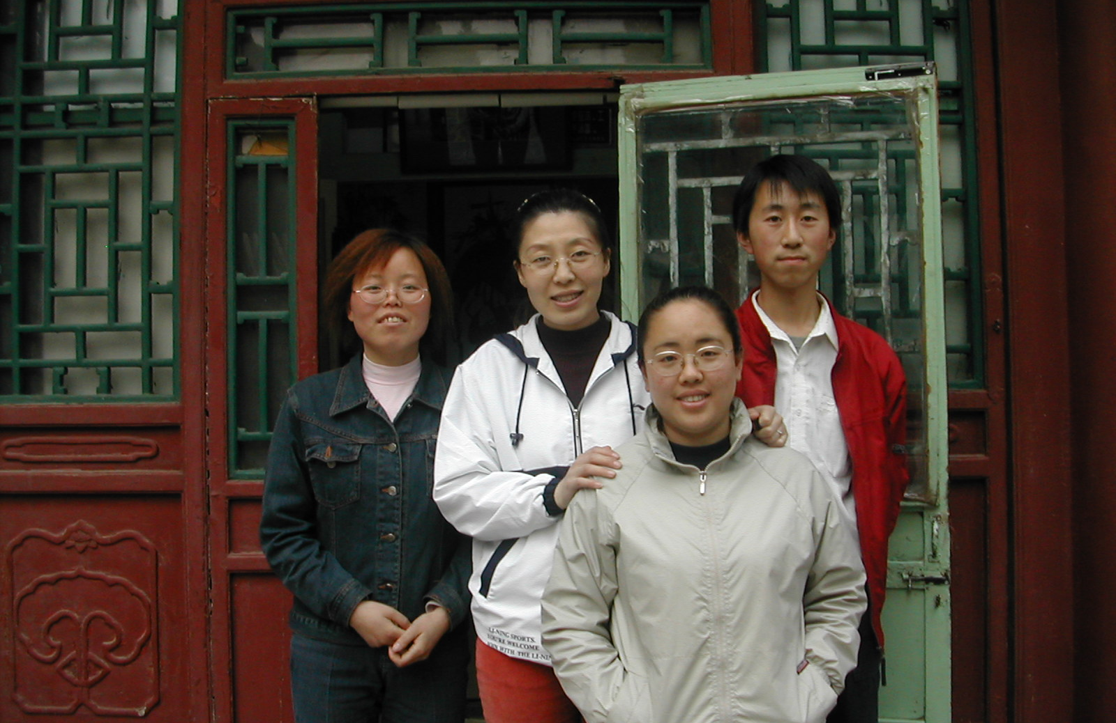
Art students in front of their gallery at the Summer Palace.
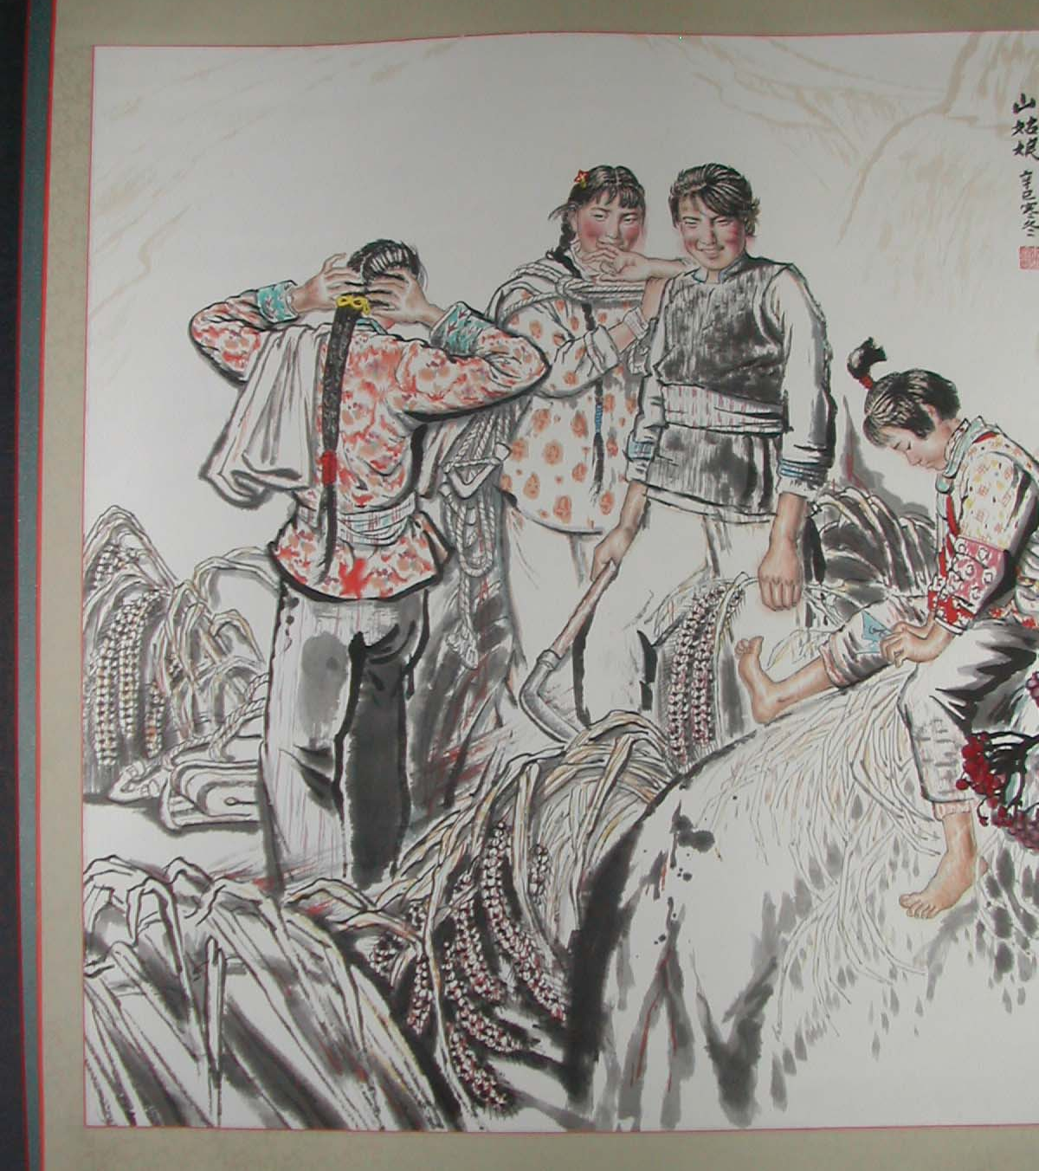
One of the purchases from the student exhibit: A 3’x5’ painting of the “Farm Girls” framed in silk.
On the way back to the hotel we stopped at a teashop and had a lesson on the various teas and how to prepare them and we sampled and bought.

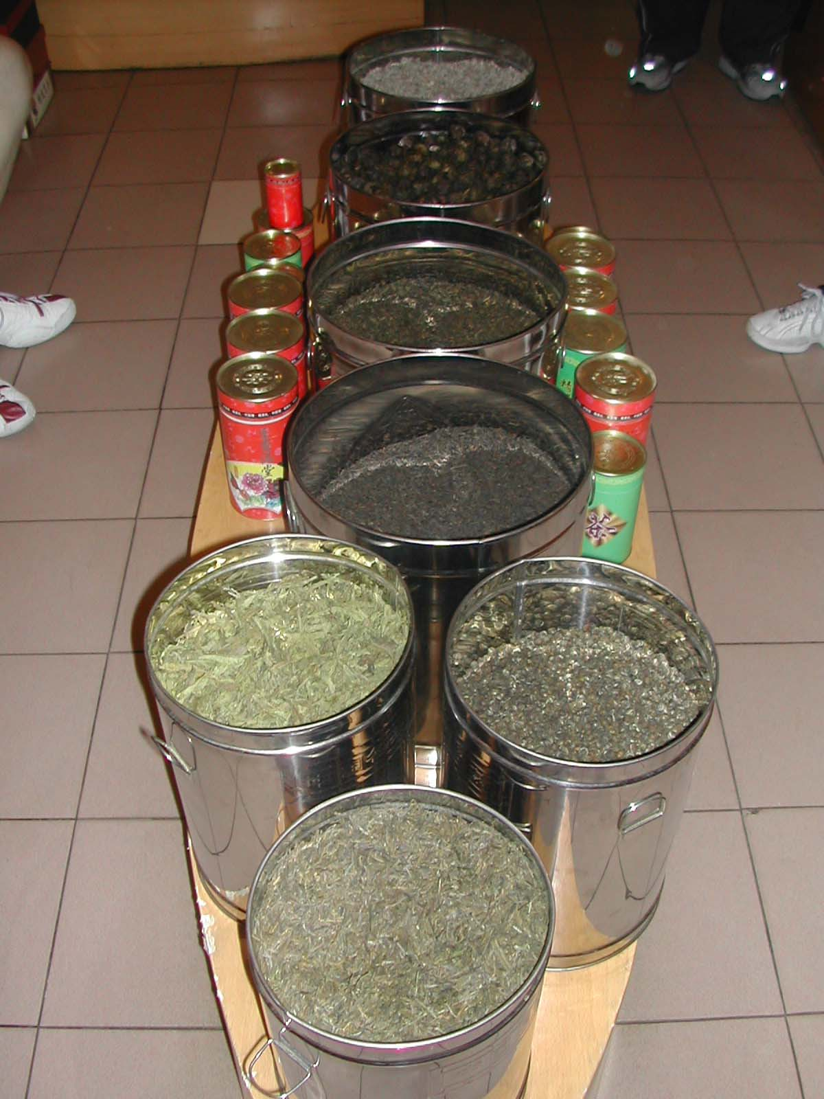
The various teas that we sampled.

21st. This morning we were off to one of man’s largest construction efforts-the Great Wall of China. We picked our guide up at a prearranged intersection and were off for about a two-hour drive. The huge parking lot was filled with buses. We took a cable car from the parking lot up to the wall. Then it was a climb on top of the wall up to one of the towers. The steps were pretty big. At the top there were a mass of people taking in the view and vendors selling “I Climbed the Great Wall” tee shirts, drawings of the wall, books and other tourist items. Below us, the wall snaked off into the mist as far as the eye could see.

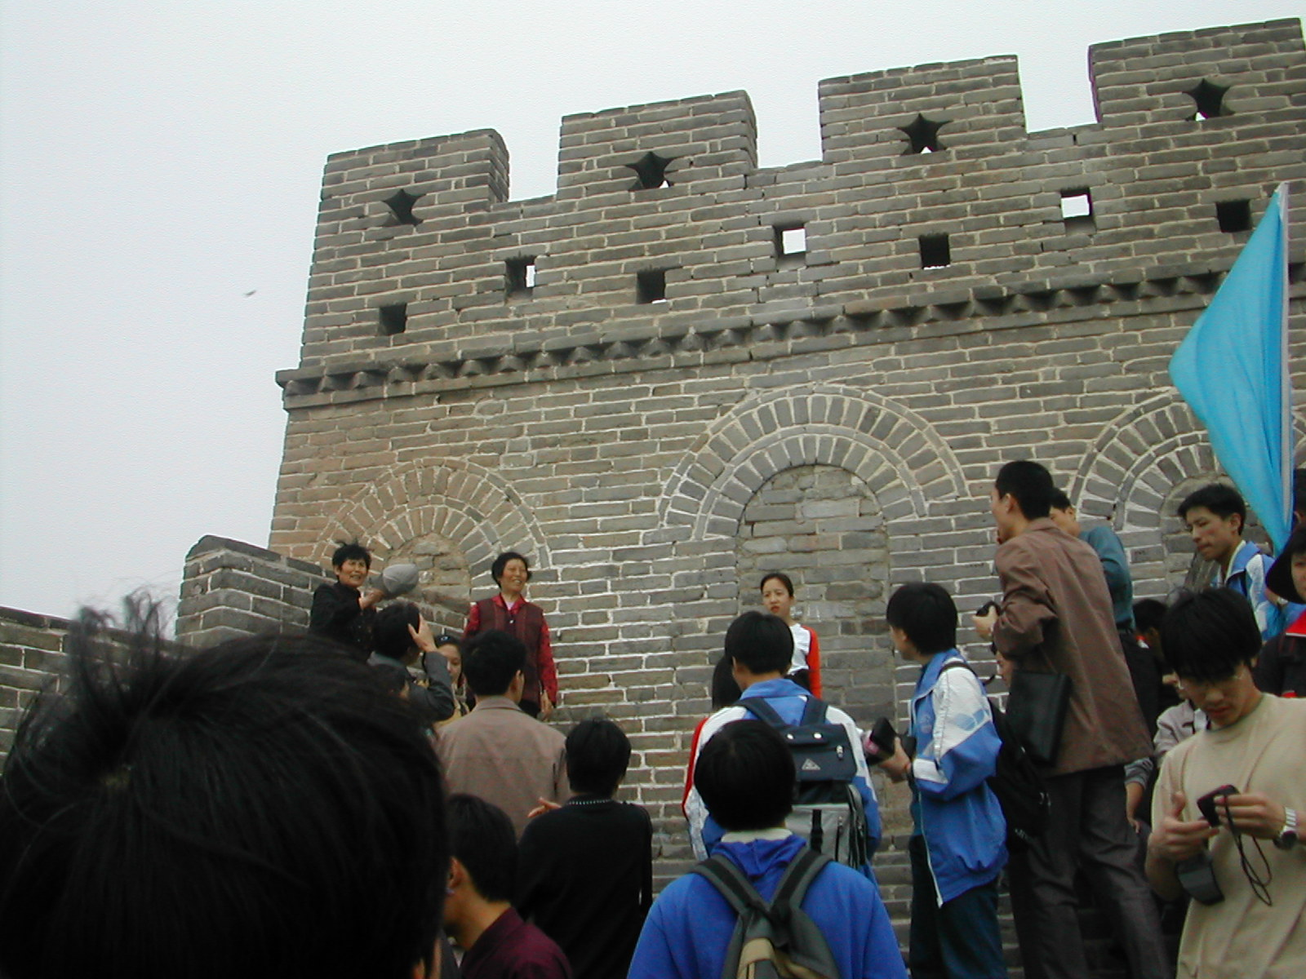
The wall high point-the Tower.
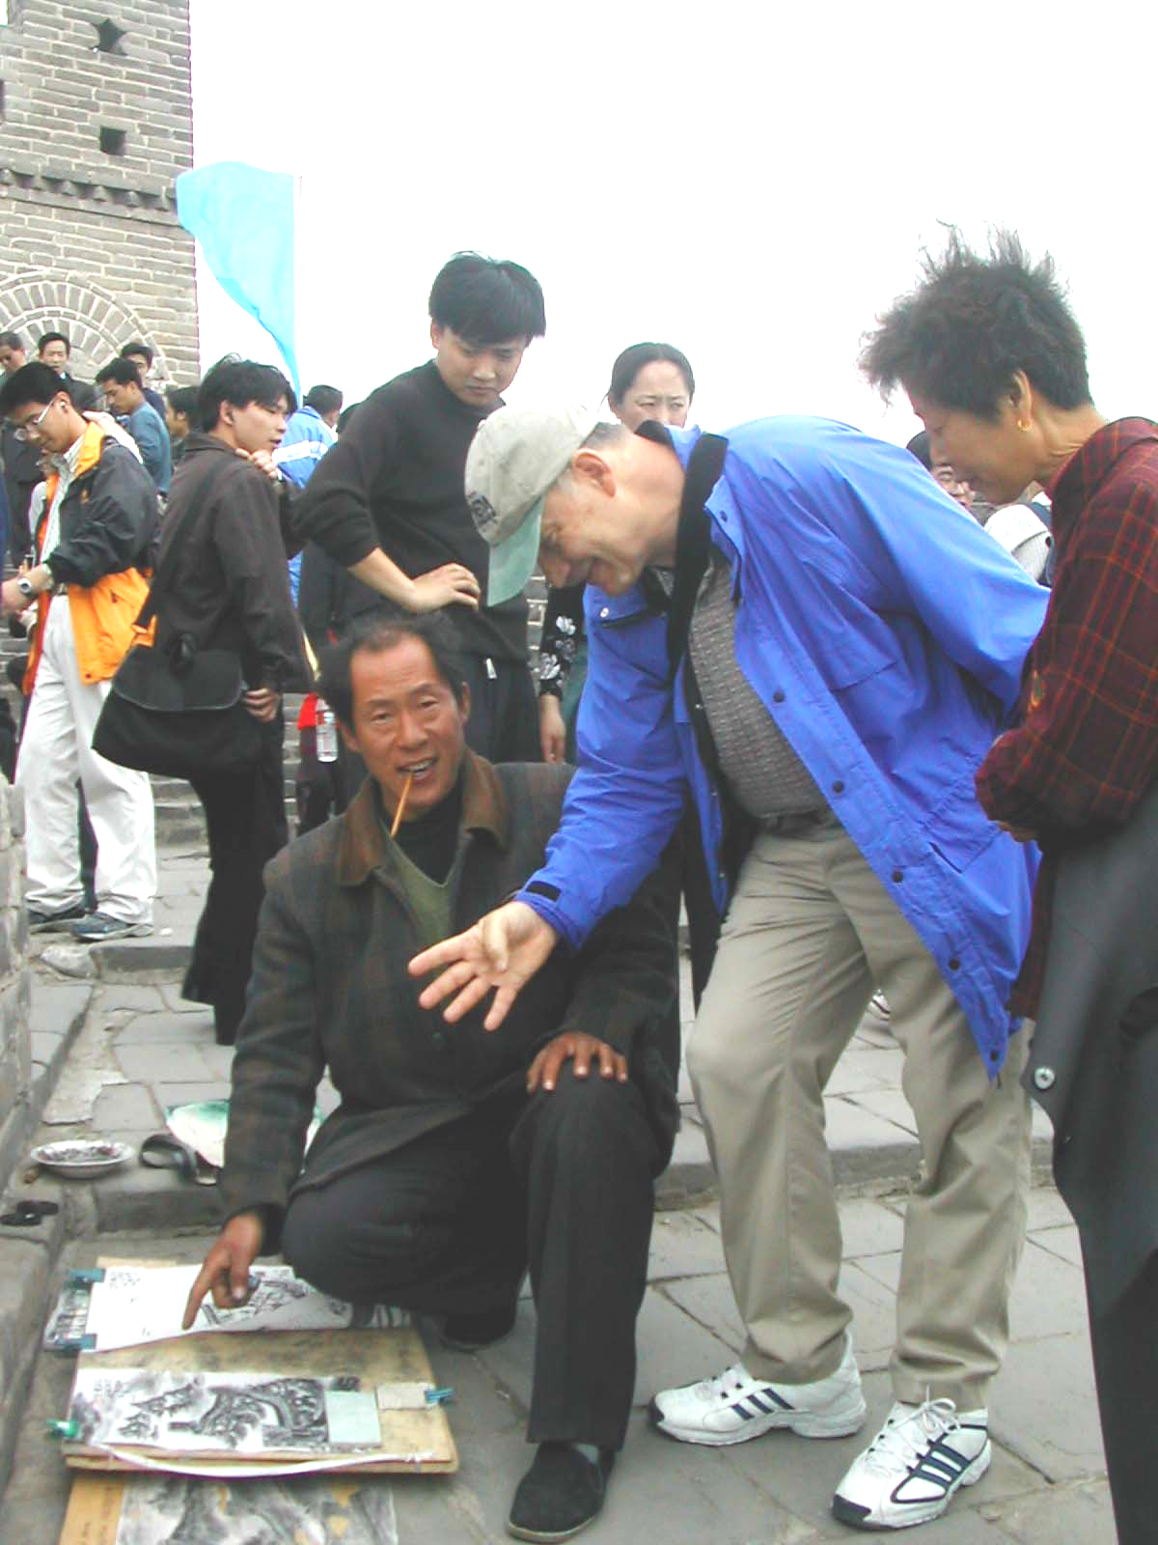
Alex bartering for a picture of the wall.

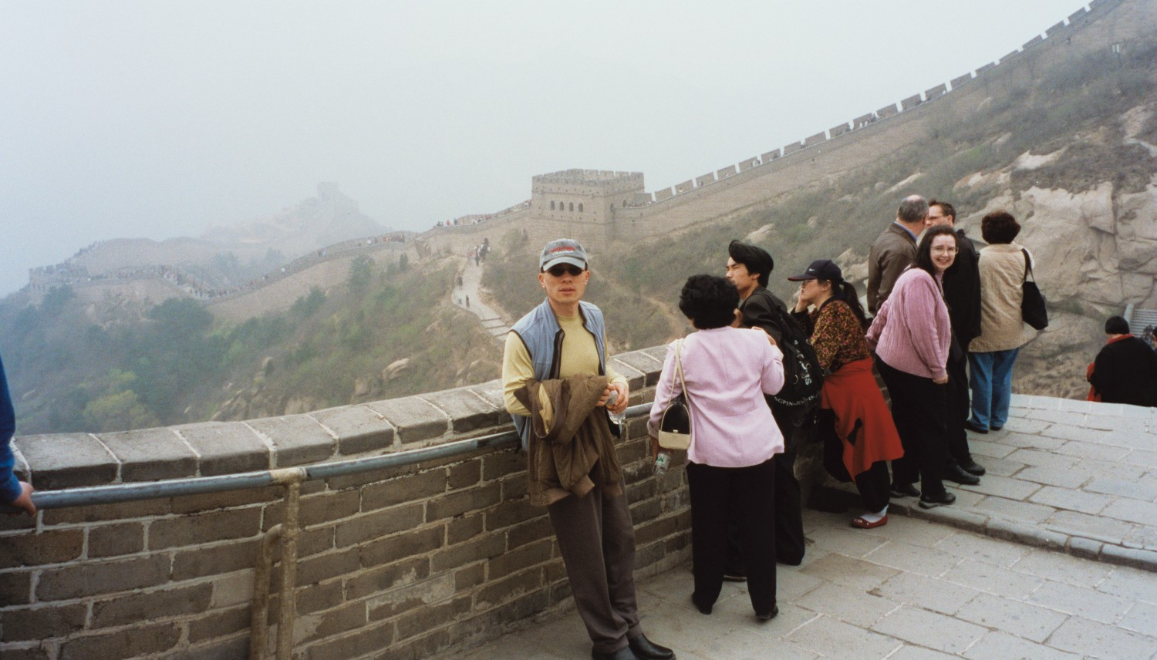
Yong with the Great Wall snaking off into the distance.
22nd. The group headed to the airport in the morning for the return trip to Seattle through Tokyo. What a tremendous experience!

Some members of the group continued their Chinese experience on to Xian, a Yangtze River cruise, the Three Gorges Dam, Guilin and Hong Kong. But, that is another story.

Yong said he’ll see you on the next trip to China (Hong Kong area), perhaps in September. It will concentrate more on table tennis and training.

